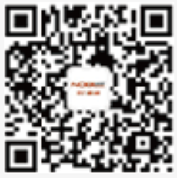

Scan QR Code for More

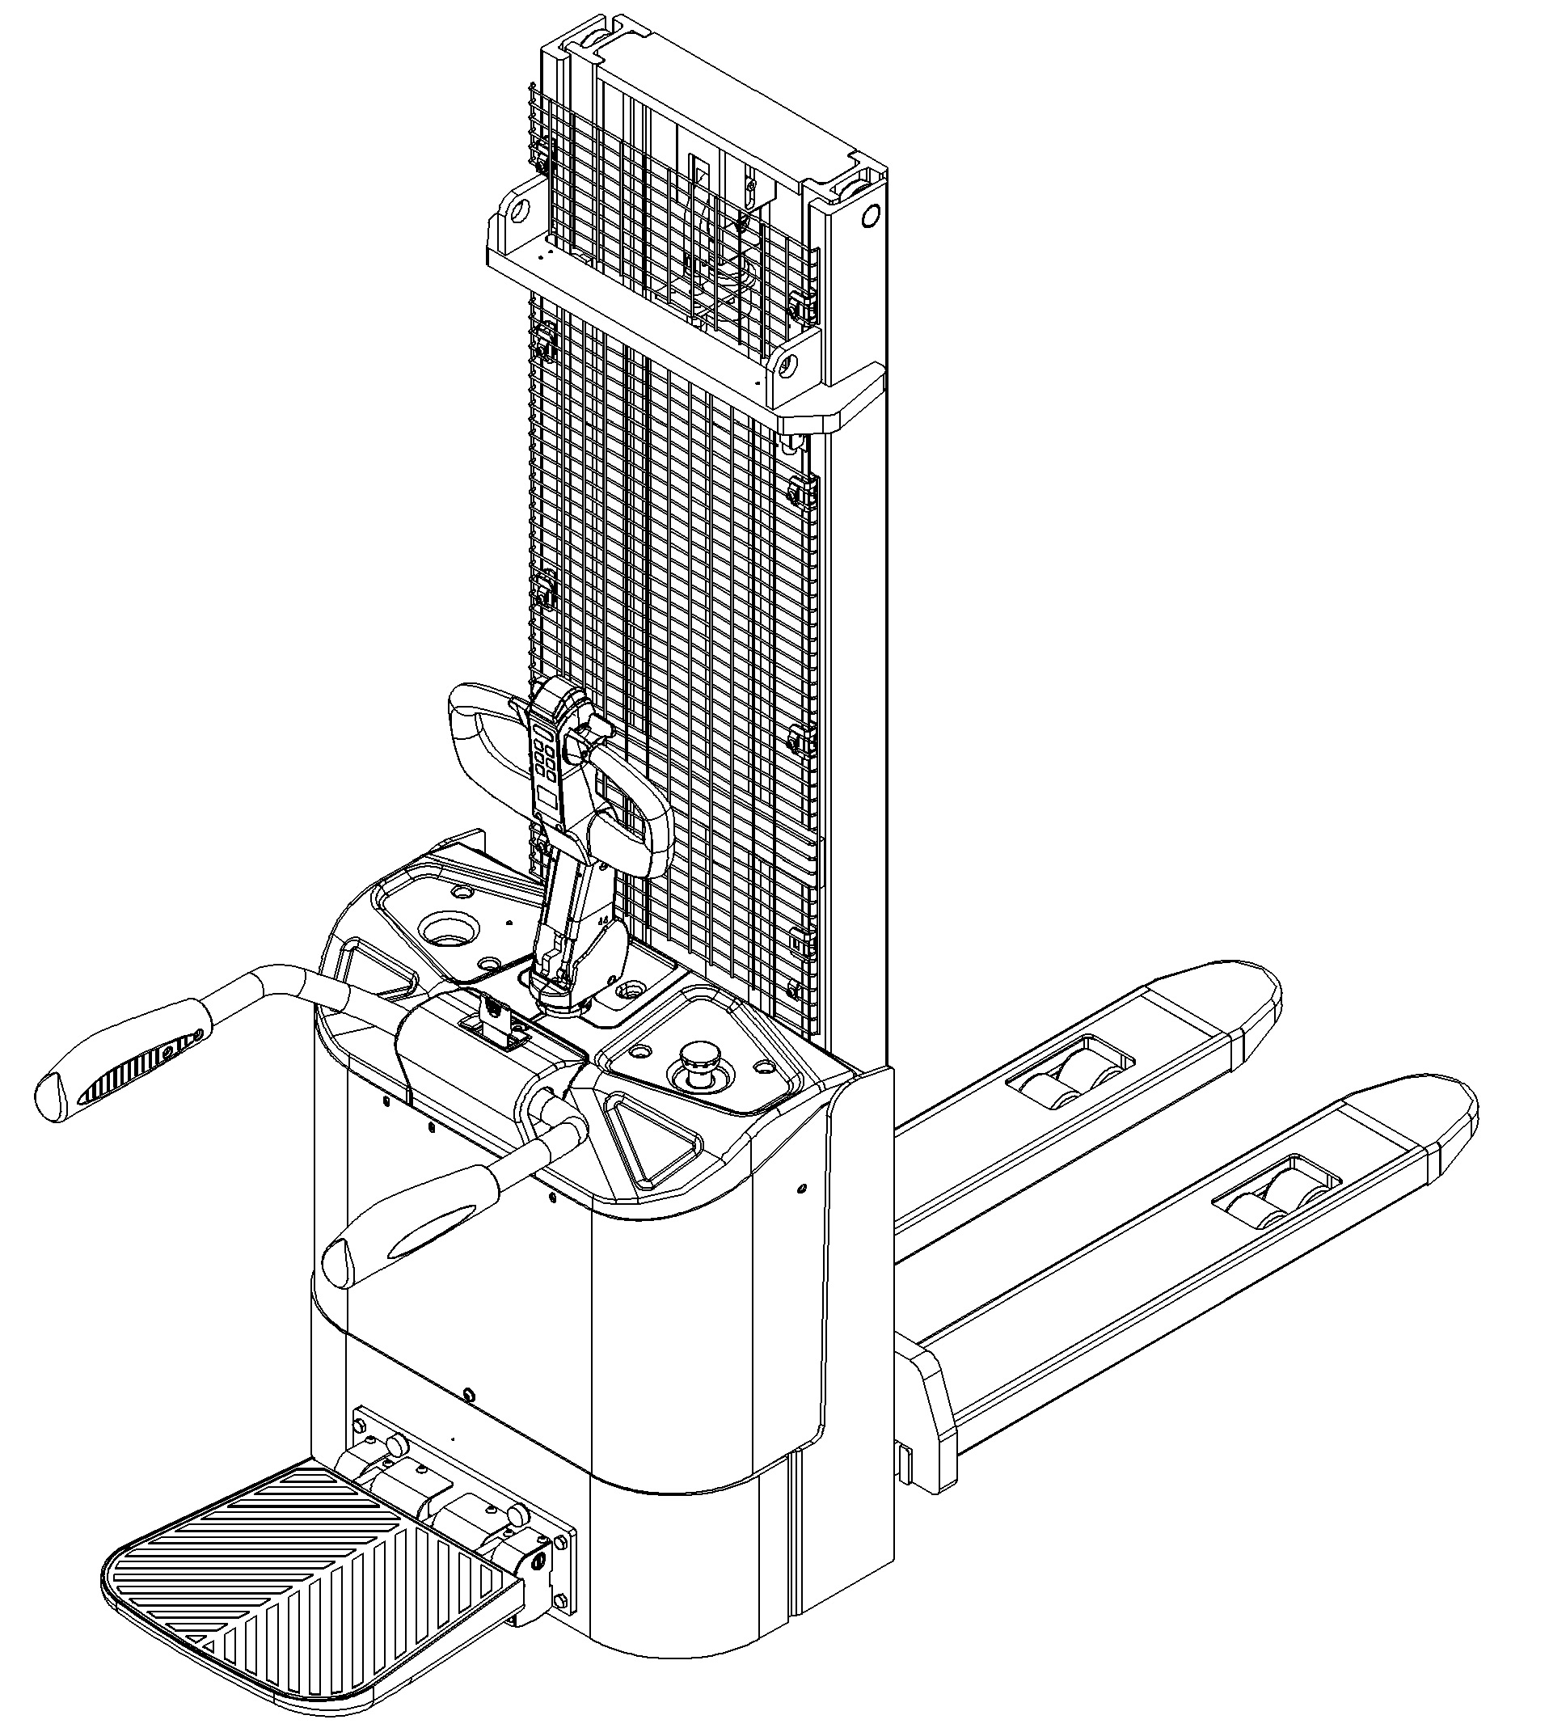

Electric Pallet Stacker PSE15-C
PARTS MANUAL
537246020101

Version：V01
Truck Identification Number From:
PSE15-C-PM01EN

Please order parts from authorized dealers of Noblelift Intelligent Equipment Co., LTD.
In order to avoid wrong delivery, all the orders for spare parts should specify the following items:
- Truck model, identification number and manufacture year.
- Orders for spare parts of mast, hydraulic transmission unit, steering axle, motor, etc. shall indicate the manufacture number of these parts.
- Codes for Noblelift spare parts are shown in the table of parts manual. Please also pay attention to the description of supply status, order quantity, etc. (check the number listed in "Mark" column of the parts manual).
"Mark" Column:
The unmarked indicates the parts are in short supply cycle.
Number 1: supply as package. Indicating these that parts are small parts and seal parts, which are supplied in package unit and in short supply cycle.
Number 2: supply with constraints. Indicating that these spare parts are not in stock and will be prepared for production after receiving the order from customers, which are in long supply cycle.
Number 3: phasing-out supply. Indicating that these parts will be replaced by new parts due to technical improvements and the current stock will not be available when these parts run out. Please check the description of technical improvements notice.
Number 4: supply as assembly. Indicating that these parts are assembly parts defined by manufacture process, which cannot be supplied as a single part.
Number 5: check other tables.
This parts manual is the property of Noblelift and can be shared under the confidential agreement only, Noblelift has the right to claim for compensation of any unauthorized use. Copy without permission is not allowed. Figures in the manual are not limited by the original design. Noblelift Intelligent Equipment Co., LTD reserves the right to improve the products for continuous technology progress.

Table of Contents
Chapter 1: Drive System 4
01 Drive Unit (537246013501) 4
02 Drive Assembly (537046013502) 6
Chapter 2: Hydraulic System 8
01 Hydraulic Assembly (537246024001) 8
01 Hydraulic Assembly (537246024001) Continuation 10
02 Hydraulic Unit (532246023501) 12
Chapter 3: Truck Frame 14
01 Fork Carriage (531846038001) 14
02 Chassis (Two Stage Mast) (537246021501) 16
02 Chassis (Two Stage Mast) (537246021501) Continuation 18
03 Chassis (Single Stage Mast) (537246021502) 20
03 Chassis (Single Stage Mast) (537246021502) Continuation 22
Chapter 4: Steering System, Braking System, Wheels 24
01 Tiller Unit (537246011001) 24
02 Control Handle (537246011002) 26
03 Steering Unit (537246031201) 28
04 Load Wheel (532646017001) 30
05 Caster (532246016501) 32
Chapter 5: Electrical Parts 34
Chapter 6: Guard Arm, Platform 38
01 Guard Arm (537246017501) 38
02 Platform (537246018001) 40
Chapter 7: Special Parts 42
01 Load Backrest (Optional) (532646040501) 42
Chapter 8: Others 44
01 Labels and Decals-EU (537246047001) 44
02 Labels and Decals-US (537246047002) 46
Appendix 48
01 Electrical Circuit Diagram (537246045501) 48
02 Hydraulic Circuit Diagram (537046045504) 49
03 Consumable Parts List 50

Chapter 1: Drive System

01 Drive Unit (537246013501)
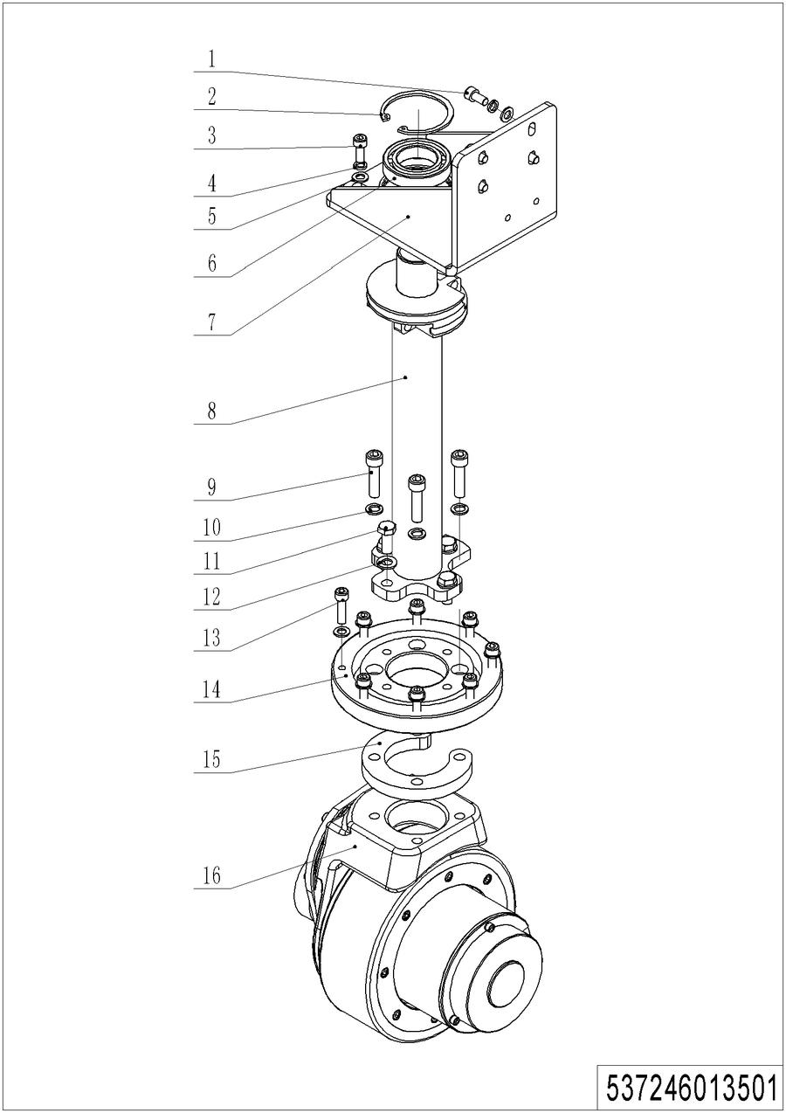
01 Drive Unit (537046013501)
No. | Item Code | Mark | Item Description | Qty. | Substitute | Note
1 | 910200200055 | 1 | Screw | 4
2 | 910401400019 | 1 | Circlip | 1
3 | 910200200057 | 1 | Screw | 4
4 | 910400500006 | 1 | Spring Washer | 8
5 | 910400100006 | 1 | Flat Washer | 16
6 | 910700200008 | 1 | Bearing | 1
7 | 537231210002 | 2 | Bracket | 1
8 | 537231210004 | 2 | Shaft Welding | 1
9 | 910200200079 | 1 | Screw | 4
10 | 910400500007 | 1 | Spring Washer | 4
11 | 910100300036 | 1 | Bolt | 4
12 | 910400100007 | 1 | Flat Washer | 4
13 | 910200200138 | 1 | Screw | 8
14 | 532213520001 | 2 | Slewing Bearing | 1
15 | 531813520005 | 2 | Plate | 1
16 | 961000700000 | 2 | Drive Unit | 1 |  | DC-0.75KW

02 Drive Assembly (537046013502)
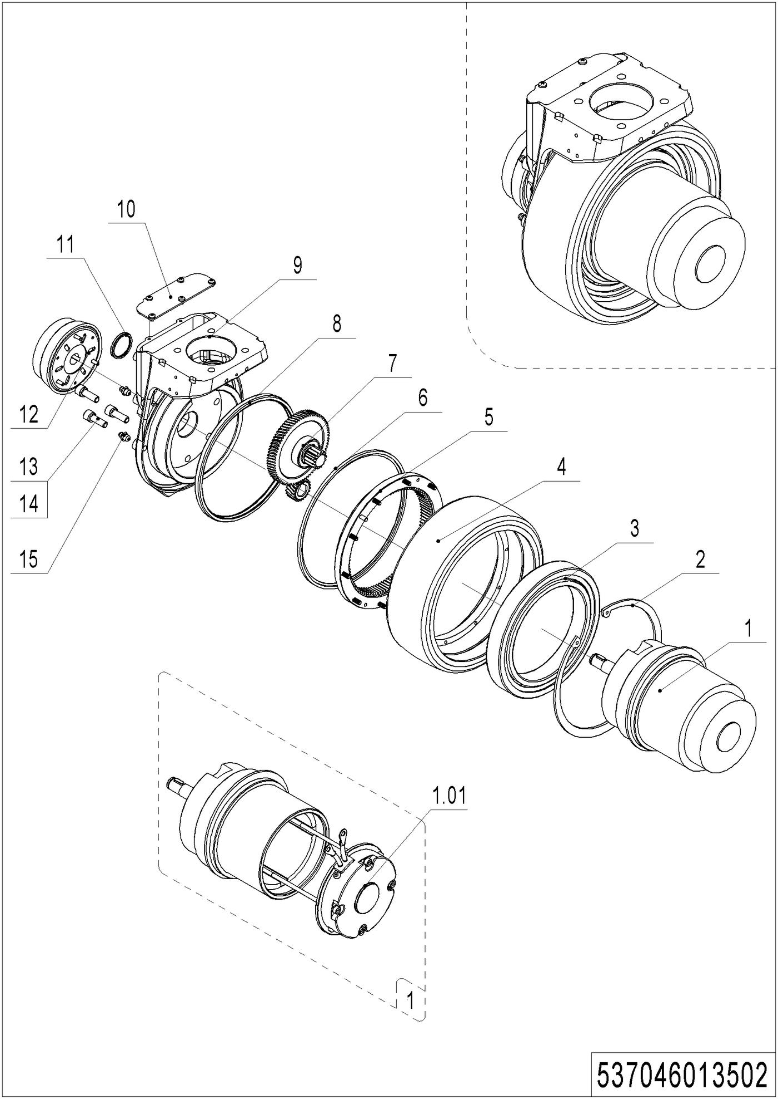
02 Drive Assembly (537046013502)
No. | Item Code | Mark | Item Description | Qty. | Substitute | Note
-- | 961000800000 | 2 | Drive Unit | 1
1 | 537098510011 | 2 | Motor | 1
1.01 | 537098510015 | 2 | Carbon Brush | 1
2 | 910401400015 | 1 | Circlip | 1
3 | 910700200053 |  | Bearing | 1
4 | 961000700008 | 2 | Tyre | 1
5 | 961000700007 | 2 | Gear | 1
6 | 961000700009 | 1 | Wiper Seal | 1
7 | 537098510012 | 2 | Gear Components | 1
8 | 961000700013 | 1 | Oil Seal | 1
9 | 537098510013 | 2 | Gearbox | 1
10 | 537098510014 | 2 | Close PlateAssembly | 1
11 | 961000700005 | 2 | Cover | 1
12 | 961000700011 | 2 | Brake | 1
13 | 910200200147 | 1 | Screw | 5
14 | 910400500019 | 1 | Spring Washer | 5
15 | 911200100003 | 1 | Oil Cup | 2

Chapter 2: Hydraulic System

01 Hydraulic Assembly (537246024001)
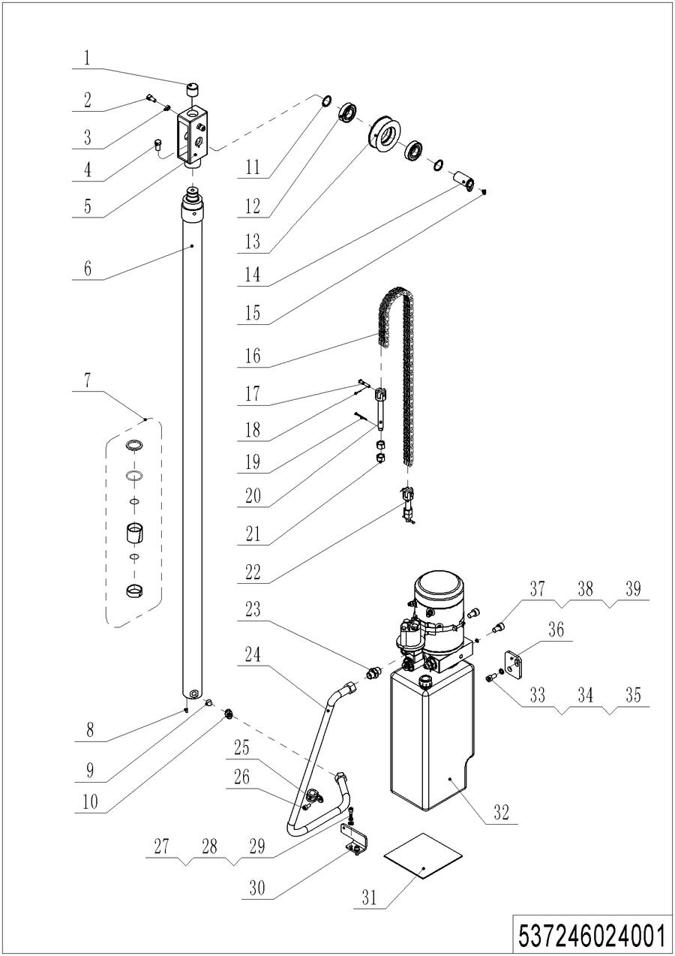
01 Hydraulic Assembly (537246024001)
No. | Item Code | Mark | Item Description | Qty. | Substitute | Note
1 | 532644020094 | 2 | Crash Pad | 1
2 | 910200200075 | 1 | Screw | 2
3 | 910300300005 | 1 | Nut | 2
4 | 910100300049 | 1 | Bolt | 1
5 | 531821520028 | 2 | Yoke | 1
6 | 531821510015 | 2 | Cylinder | 1 |  | Lift Height 1600
6 | 531821510016 | 2 | Cylinder | 1 |  | Lift Height 2000
6 | 532644010031 | 2 | Cylinder | 1 |  | Lift Height 2900
6 | 532644010037 | 2 | Cylinder | 1 |  | Lift Height 3200
6 | 532644010041 | 2 | Cylinder | 1 |  | Lift Height 3600
7 | 532698510001 | 2 | Seal Kit | 1
8 | 950600300001 | 2 | Safety Valve | 1
9 | 950400400003 | 2 | Joint | 1
10 | 910600400020 | 1 | Spring Pin | 1
11 | 910700200021 | 1 | Bearing | 2
12 | 940200400003 | 2 | Sprocket | 1
13 | 940600500008 | 2 | Washer | 2
14 | 532644010035 | 2 | Pin | 1
15 | 910200400014 | 1 | Screw | 1
16 | 532644010083 | 2 | Chain | 1 |  | Lift Height 2900
16 | 532644010084 | 2 | Chain | 1 |  | Lift Height 3200
16 | 532644010085 | 2 | Chain | 1 |  | Lift Height 3600
16 | 532643510087 | 2 | Chain | 1 |  | Lift Height 1600
16 | 531821510014 | 2 | Chain | 1 |  | Lift Height 2000
17 | 941100800008 | 1 | Pin | 2
18 | 910600600015 | 1 | Cotter Pin | 2
19 | 910600600037 | 1 | Cotter Pin | 2
20 | 532643520137 | 2 | Chain Anchor | 1
21 | 910300200008 | 1 | Nut | 4
22 | 532643520137 | 2 | Chain Anchor | 1 |  | Lift Height 2000

01 Hydraulic Assembly (537246024001) Continuation

01 Hydraulic Assembly (537246024001) Continuation
No. | Item Code | Mark | Item Description | Qty. | Substitute | Note
22 | 532644020096 | 2 | Chain Anchor | 1 |  | Optional for Other Models
23 | 950400300007 | 2 | Joint | 1
24 | 537224020000 | 2 | Hose | 1
25 | 951000100003 | 2 | Hose Clamp | 1
26 | 910200200033 | 1 | Screw | 1
27 | 910200200035 | 1 | Screw | 2
28 | 910400500005 | 1 | Spring Washer | 2
29 | 910400100005 | 1 | Flat Washer | 2
30 | 537224020001 | 2 | Fixing Base | 1
31 | 532223520002 | 2 | Crash Pad | 1
32 | ------------ | 5 | 泵站 | 1 |  | Check 532246023501
33 | 910200200055 | 1 | Screw | 2
34 | 910400500006 | 1 | Spring Washer | 2
35 | 910400100006 | 1 | Flat Washer | 2
36 | 532223520001 | 2 | Plate | 2
37 | 910200200075 | 1 | Screw | 2
38 | 910400500007 | 1 | Spring Washer | 2
39 | 910400100007 | 1 | Flat Washer | 2

02 Hydraulic Unit (532246023501)
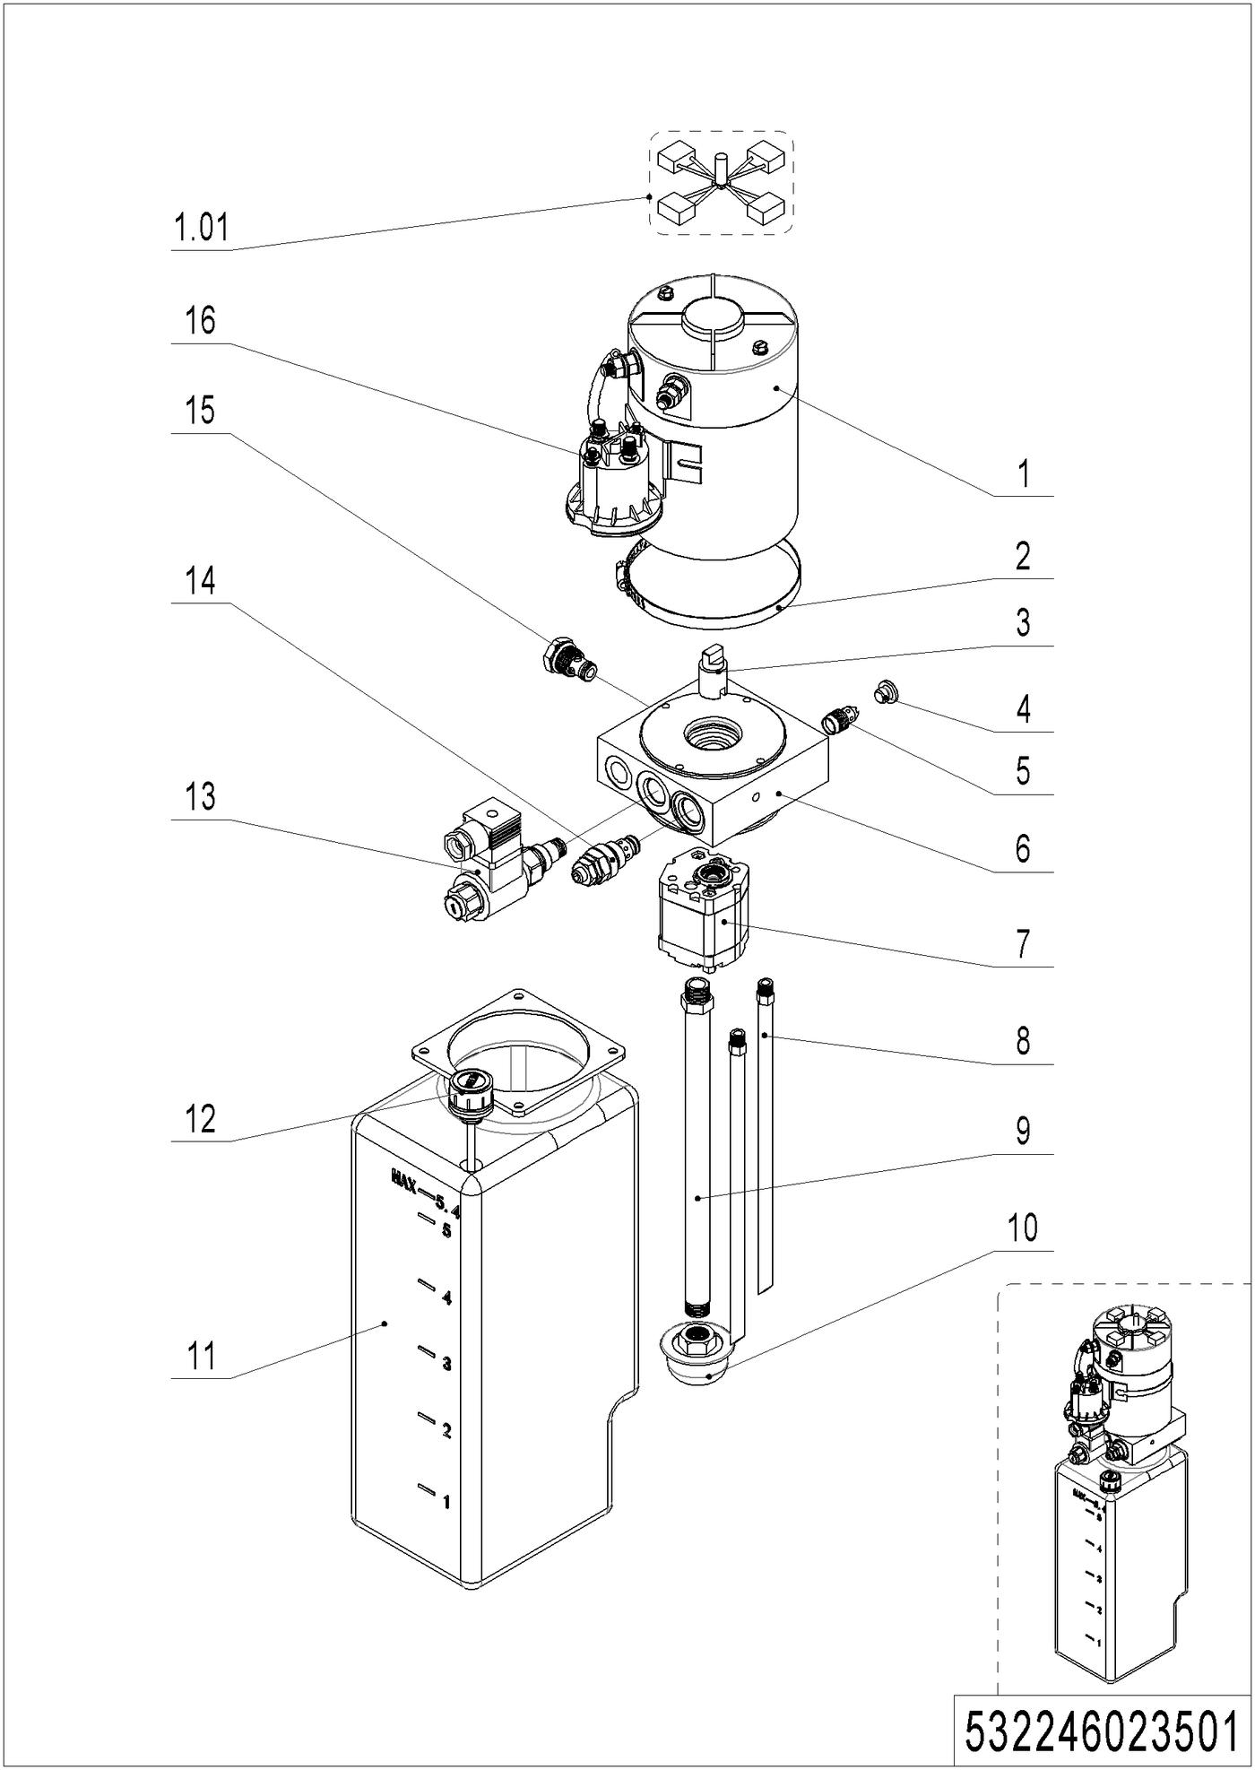
02 Hydraulic Unit (532246023501)
No. | Item Code | Mark | Item Description | Qty. | Substitute | Note
-- | 950900100069 | 2 | Pump Unit | 1
1 | 532298510037 | 2 | Motor | 1
1.01 | 532298510026 | 2 | Carbon Brush | 1
2 | 532298510040 | 2 | Hose Clamp | 1
3 | 532298520007 | 2 | Coupling | 1
4 | 532298520003 | 2 | End Cap | 1
5 | 532298510027 | 2 | Valve | 1
6 | 532298520006 | 2 | Valve Block | 1
7 | 532298510032 | 2 | Gear Pump | 1
8 | 532298520004 | 2 | Pipe | 2
9 | 532298520005 | 2 | Oil Tube | 1
10 | 532298510031 | 2 | Filter | 1
11 | 532298510029 | 2 | Tank | 1
12 | 532298510030 | 2 | Cap-Tank | 1
13 | 532298510042 | 2 | Magnetic Valve | 1
14 | 532298510035 | 2 | Overflow Valve | 1
15 | 532298510028 | 2 | Check Valve | 1
16 | 532298510036 | 2 | Switch | 1

Chapter 3: Truck Frame

01 Fork Carriage (531846038001)
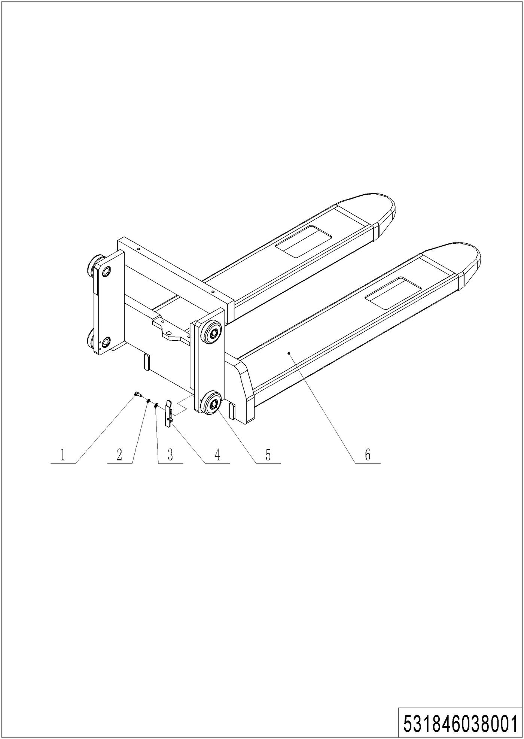
01 Fork Carriage (531846038001)
No. | Item Code | Mark | Item Description | Qty. | Substitute | Note
1 | 910200200035 | 1 | Screw | 2 |  | Single Mast
2 | 910400500005 | 1 | Spring Washer | 2 |  | Single Mast
3 | 910400100005 | 1 | Flat Washer | 2 |  | Single Mast
4 | 531838020010 | 2 | Stop Plate | 1 |  | Single Mast
5 | 940200300008 |  | Compound Roller | 4
6 | 531838010002 | 2 | Fork(,570x1150) | 1 |  | Single mast
6 | 531838010003 | 2 | Fork(,685x1150) | 1 |  | Single mast
6 | 531838010000 | 2 | Fork(570x1150) | 1 |  | Two-stage mast
6 | 531838010001 | 2 | Fork(685x1150) | 1 |  | Two-stage mast

02 Chassis (Two Stage Mast) (537246021501)
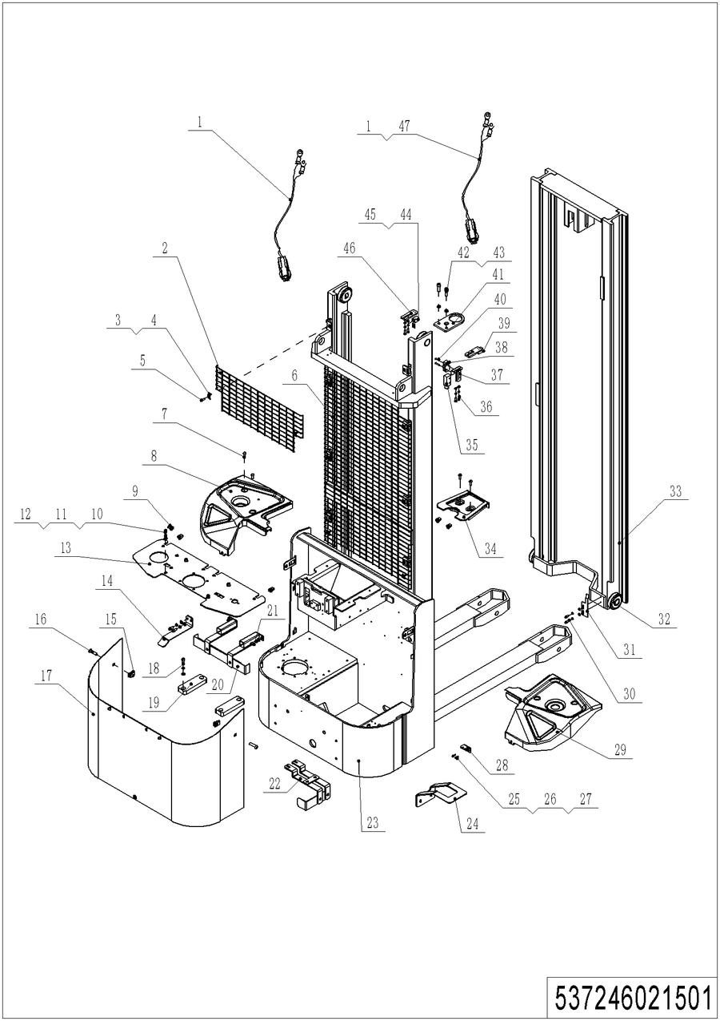

02 Chassis (Two Stage Mast) (537246021501)
No. | Item Code | Mark | Item Description | Qty. | Substitute | Note
1 | 531833010002 | 2 | Wire | 2
2 | 531821520045 | 2 | Protective Frame | 1
3 | 320443020321 | 2 | Press Plate | 8
4 | 940400400001 | 1 | Cage Nut | 8
5 | 910200200038 | 1 | Screw | 8
6 | 531821520042 | 2 | Protective Frame | 1 |  | 2900
6 | 531821520041 | 2 | Protective Frame | 1 |  | 3200
6 | 531821520040 | 2 | Protective Frame | 1 |  | 3600
7 | 941100100012 | 1 | Screw,M8x20 | 8
8 | 509821520025 | 2 | Protective Cover | 1
9 | 940400400002 | 1 | Cage Nut | 6
10 | 910200200054 | 1 | Screw | 8
11 | 910400500006 | 1 | Spring Washer | 16
12 | 910400100006 | 1 | Flat Washer | 16
13 | 537221520014 | 2 | Mounting Plate | 1
14 | 537221520016 | 2 | Bracket | 1
15 | 940400400003 | 1 | Cage Nut | 2
16 | 941100100004 | 1 | Screw | 2
17 | 509821510001 | 2 | Cover | 1
18 | 910200200058 | 1 | Screw | 4
19 | 537237020006 | 2 | Subplate | 2
20 | 537237010000 | 2 | Mounting Plate | 1
21 | 910200200055 | 1 | Screw | 4
22 | 537237010001 | 2 | Mounting Plate | 1
23 | 537221510000 | 2 | Chassis(3600,570x1150) | 1 |  | 3600,570x1150
23 | 537221510002 | 2 | Chassis(3200,570x1150) | 1 |  | 3200,570x1150
23 | 537221510004 | 2 | Chassis(2900,570x1150) | 1 |  | 2900,570x1150
23 | 537221510006 | 2 | Chassis(3600,685x1150) | 1 |  | 3600,685x1150
23 | 537221510007 | 2 | Chassis(3200,685x1150) | 1 |  | 3200,685x1150
23 | 537221510008 | 2 | Chassis(2900,685x1150) | 1 |  | 2900,685x1150

02 Chassis (Two Stage Mast) (537246021501) Continuation
02 Chassis (Two Stage Mast) (537246021501) Continuation
No. | Item Code | Mark | Item Description | Qty. | Substitute | Note
24 | 537221520015 | 2 | Plate | 1
25 | 910200200033 | 1 | Screw | 2
26 | 910400500005 | 1 | Spring Washer | 10
27 | 910400100005 | 1 | Flat Washer | 10
28 | 531821520031 | 2 | Mounting Plate | 1
29 | 509821520022 | 2 | Protective Cover | 1
30 | 910200300017 | 1 | Screw | 2
31 | 531821520001 | 2 | Stop Plate | 1
32 | 940200300007 |  | Compound Roller | 4
33 | 537221510001 | 2 | Inner Mast(3600) | 1
33 | 537221510003 | 2 | Inner Mast(3200) | 1
33 | 537221510005 | 2 | Inner Mast(2900) | 1
34 | 509821520021 | 2 | Protective Cover | 1
35 | 920200300008 | 2 | Protective Cover | 1
36 | 910200200035 | 1 | Screw | 6
37 | 531821520006 | 2 | Fixing Plate | 1
38 | 920200300001 | 2 | Microswitch | 1
39 | 920200400033 | 2 | Proximity Switch | 1
40 | 910200400006 | 1 | Screw | 2
41 | 532644020097 | 2 | Fixing Plate | 1
42 | 910200200077 | 1 | Screw | 2
43 | 910400500007 | 1 | Spring Washer | 2
44 | 910200500015 | 1 | Screw | 4
45 | 920200400032 | 2 | Proximity Switch | 1
46 | 531821520007 | 2 | Fixing Plate | 2
47 | 531833010018 | 2 | Wire Harness | 1

03 Chassis (Single Stage Mast) (537246021502)
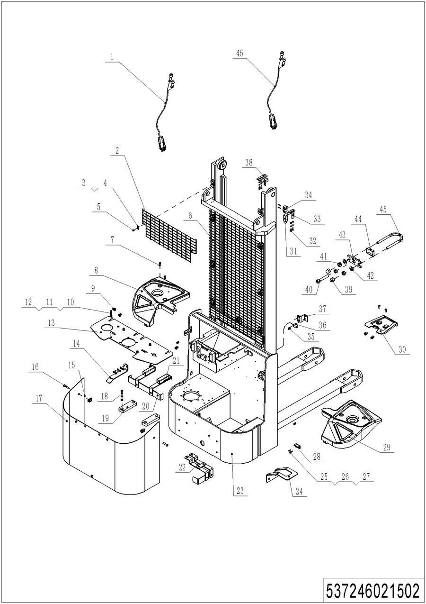
03 Chassis (Single Stage Mast) (537246021502)
No. | Item Code | Mark | Item Description | Qty. | Substitute | Note
1 | 531833010002 | 2 | Wire | 2
2 | 531821520045 | 2 | Protective Frame | 1
3 | 320443020321 | 2 | Press Plate | 8
4 | 940400400001 | 1 | Cage Nut | 8
5 | 910200200038 | 1 | Screw | 8
6 | 531821520062 | 2 | Protective Frame | 1 |  | 2000
6 | 531821520061 | 2 | Protective Frame | 1 |  | 1600
7 | 941100100012 | 1 | Screw,M8x20 | 8
8 | 509821520025 | 2 | Protective Cover | 1
9 | 940400400002 | 1 | Cage Nut | 6
10 | 910200200054 | 1 | Screw | 8
11 | 910400500006 | 1 | Spring Washer | 16
12 | 910400100006 | 1 | Flat Washer | 16
13 | 537221520014 | 2 | Mounting Plate | 1
14 | 537221520016 | 2 | Bracket | 1
15 | 940400400003 | 1 | Cage Nut | 2
16 | 941100100004 | 1 | Screw | 2
17 | 509821510001 | 2 | Cover | 1
18 | 910200200058 | 1 | Screw | 4
19 | 537237020006 | 2 | Subplate | 2
20 | 537237010000 | 2 | Mounting Plate | 1
21 | 910200200055 | 1 | Screw | 4
22 | 537237010001 | 2 | Mounting Plate | 1
23 | 537221510009 | 2 | Chassis(2000,570x1150) | 1
23 | 537221510010 | 2 | Chassis(1600,570x1150) | 1
23 | 537221510011 | 2 | Chassis(2000,685x1150) | 1
23 | 537221510012 | 2 | Chassis(1600,685x1150) | 1
24 | 537221520015 | 2 | Plate | 1
25 | 910200200033 | 1 | Screw | 4
26 | 910400500005 | 1 | Spring Washer | 10

03 Chassis (Single Stage Mast) (537246021502) Continuation
03 Chassis (Single Stage Mast) (537246021502) Continuation
No. | Item Code | Mark | Item Description | Qty. | Substitute | Note
27 | 910400100005 | 1 | Flat Washer | 10
28 | 531821520031 | 2 | Mounting Plate | 1
29 | 509821520022 | 2 | Protective Cover | 1
30 | 509821520021 | 2 | Protective Cover | 1
31 | 920200300008 | 2 | Protective Cover | 1
32 | 910200200035 | 1 | Screw | 4
33 | 531821520006 | 2 | Fixing Plate | 1
34 | 920200300001 | 2 | Microswitch | 1
35 | 910200500015 | 1 | Screw | 4 |  | 2 for 1600 Model
36 | 920200400032 | 2 | Proximity Switch | 2 |  | 1 for 1600 Model
37 | 532021520053 | 2 | Fixing Plate | 1
38 | 531821520007 | 2 | Fixing Plate | 1
39 | 910301000001 | 1 | Nut | 2
40 | 910200200083 | 1 | Screw | 1
41 | 910300100007 | 1 | Nut | 3
42 | 910400100007 | 1 | Flat Washer | 2
43 | 255044020130 | 2 | Fixing Base | 1
44 | 255044020129 | 2 | Protective Cover | 1
45 | 531821520056 | 2 | Bolt | 1
46 | 531833010018 | 2 | Wire Harness | 1

Chapter 4: Steering System, Braking System, Wheels

01 Tiller Unit (537246011001)
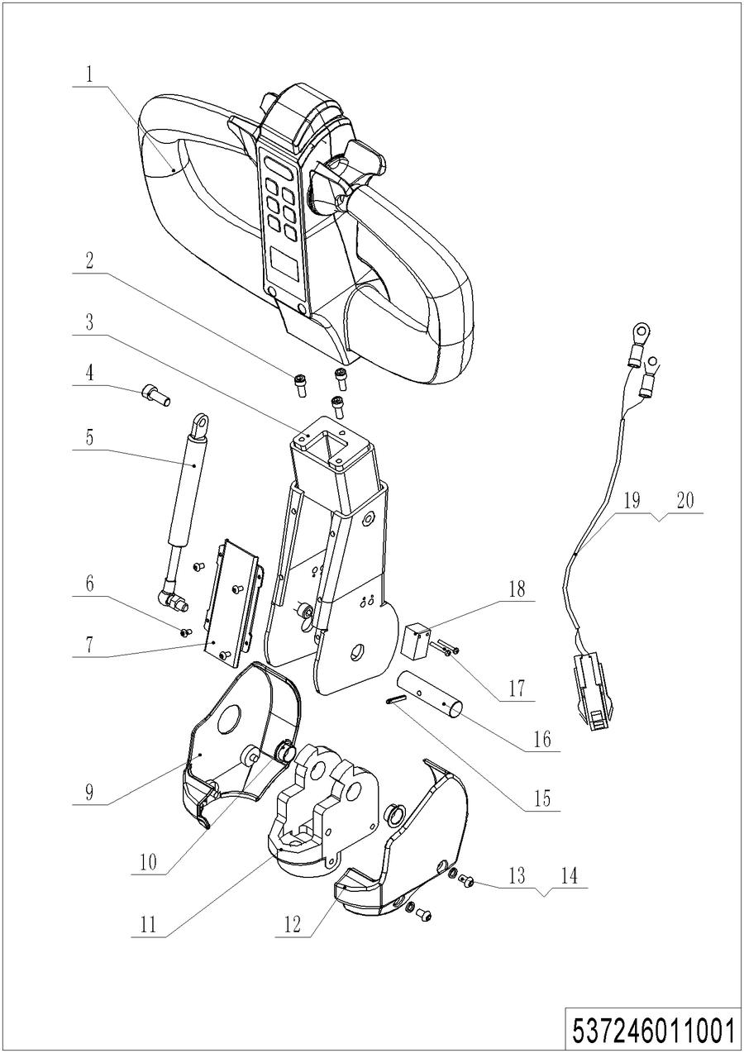
01 Tiller Unit (537246011001)
No. | Item Code | Mark | Item Description | Qty. | Substitute | Note
1 | ------------ | 5 | 手柄头 | 1 |  | Check 537246011002
2 | 910200200035 | 1 | Screw | 3
3 | 537211010000 | 2 | Tiller | 1
4 | 910200200057 | 1 | Screw | 1
5 | 940400100044 | 2 | Air Spring | 1
6 | 910200300005 | 1 | Screw | 4
7 | 537211020004 | 2 | Close Plate | 1
8 | 505611020007 | 1 | Screw | 1
9 | 535911020005 | 2 | Protective Cover | 1
10 | 940500200002 | 1 | Bushing | 1
11 | 535911020009 | 2 | Bracket | 1
12 | 535911020006 | 2 | Protective Cover | 1
13 | 910400500005 | 1 | Spring Washer | 4
14 | 910200300016 | 1 | Screw | 4
15 | 910600400013 | 1 | Spring Pin | 1
16 | 505611020008 | 2 | Axle | 1
17 | 910200500015 | 1 | Screw | 2
18 | 920200400034 | 2 | Proximity Switch | 1
19 | 537233010001 | 2 | Wire Harness | 1
20 | 531833010002 | 2 | Wire | 1

02 Control Handle (537246011002)
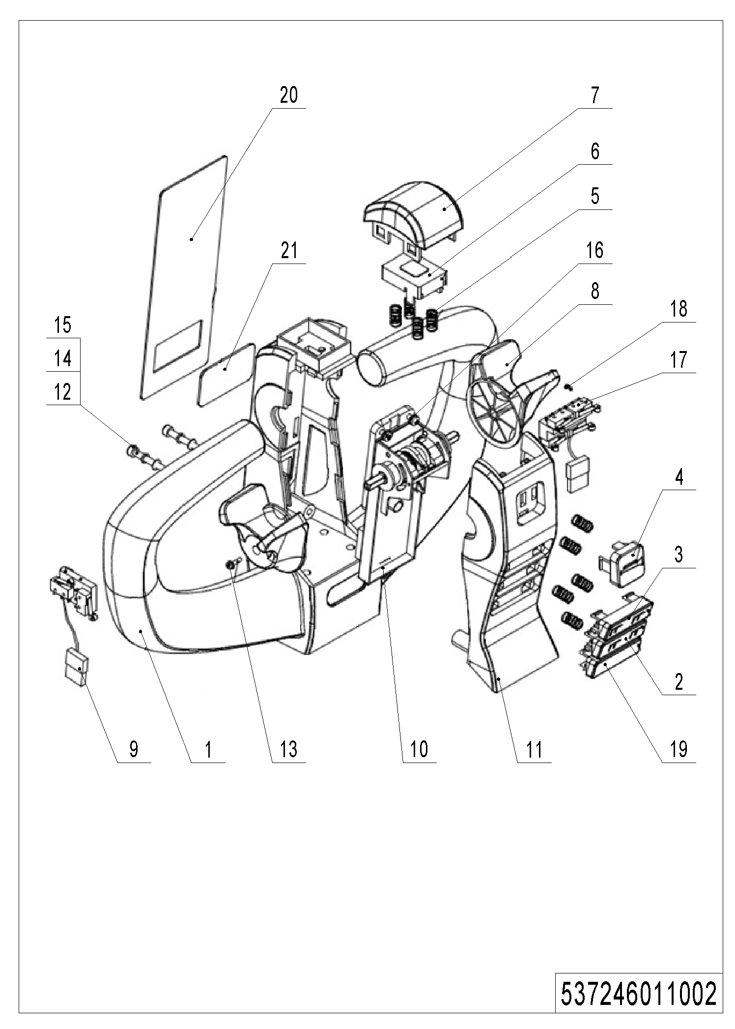
02 Control Handle (537246011002)
No. | Item Code | Mark | Item Description | Qty. | Substitute | Note
1 | 509898520001 | 2 | Plastic Handle | 1
2 | 509898520002 | 2 | Button | 1
3 | 509898520003 | 2 | Button | 1
4 | 509898520004 | 2 | Button | 1
5 | 537098520005 | 1 | Spring | 10 |  | φ0.6xφ8.7x16
6 | 509898520006 | 2 | Cover | 1
7 | 509898520007 | 2 | Button | 1
8 | 509898520008 | 2 | Dial Key | 2
9 | 509898510000 | 2 | Wire Harness | 1
10 | 537298510001 | 2 | Accelerator | 1
11 | 509898520009 | 2 | Cover | 1
12 | 910200200027 | 1 | Screw | 2
13 | 910201900002 | 1 | Screw | 2
14 | 910400500004 | 1 | Spring Washer | 2
15 | 910400100004 | 1 | Flat Washer | 2
16 | 910201900003 | 1 | Screw | 4
17 | 509898510002 | 2 | Wire Harness | 1
18 | 910201400001 | 1 | Screw | 2
19 | 509898520016 | 2 | Button | 1
20 | 509898520017 | 2 | Button | 1
21 | 509898510003 | 2 | Screen Protection | 1

03 Steering Unit (537246031201)
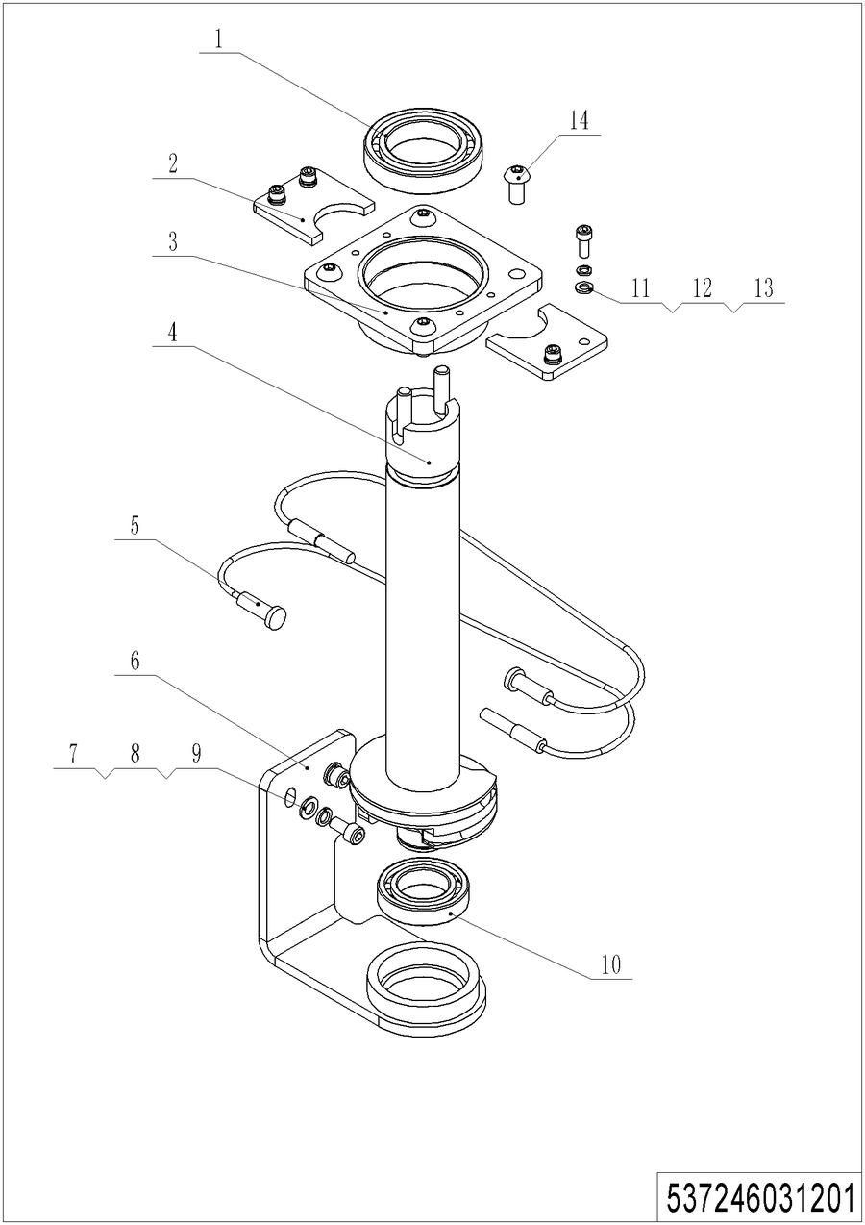
03 Steering Unit (537246031201)
No. | Item Code | Mark | Item Description | Qty. | Substitute | Note
1 | 910700200009 | 2 | Bearing | 1
2 | 537231220010 | 2 | Fixing Plate | 2
3 | 537231210000 | 2 | Fixing Base | 1
4 | 537231210001 | 2 | Shaft Welding | 1
5 | 535931210003 | 2 | Wirerope | 2
6 | 537231210003 | 2 | Bracket | 1
7 | 910200200055 | 1 | Screw | 2
8 | 910400500006 | 1 | Spring Washer | 2
9 | 910400100006 | 1 | Flat Washer | 2
10 | 910700200007 | 2 | Bearing | 1
11 | 910200200035 | 1 | Screw | 4
12 | 910400500005 | 1 | Spring Washer | 4
13 | 910400100005 | 1 | Flat Washer | 4
14 | 910200300028 | 1 | Screw | 4

04 Load Wheel (532646017001)
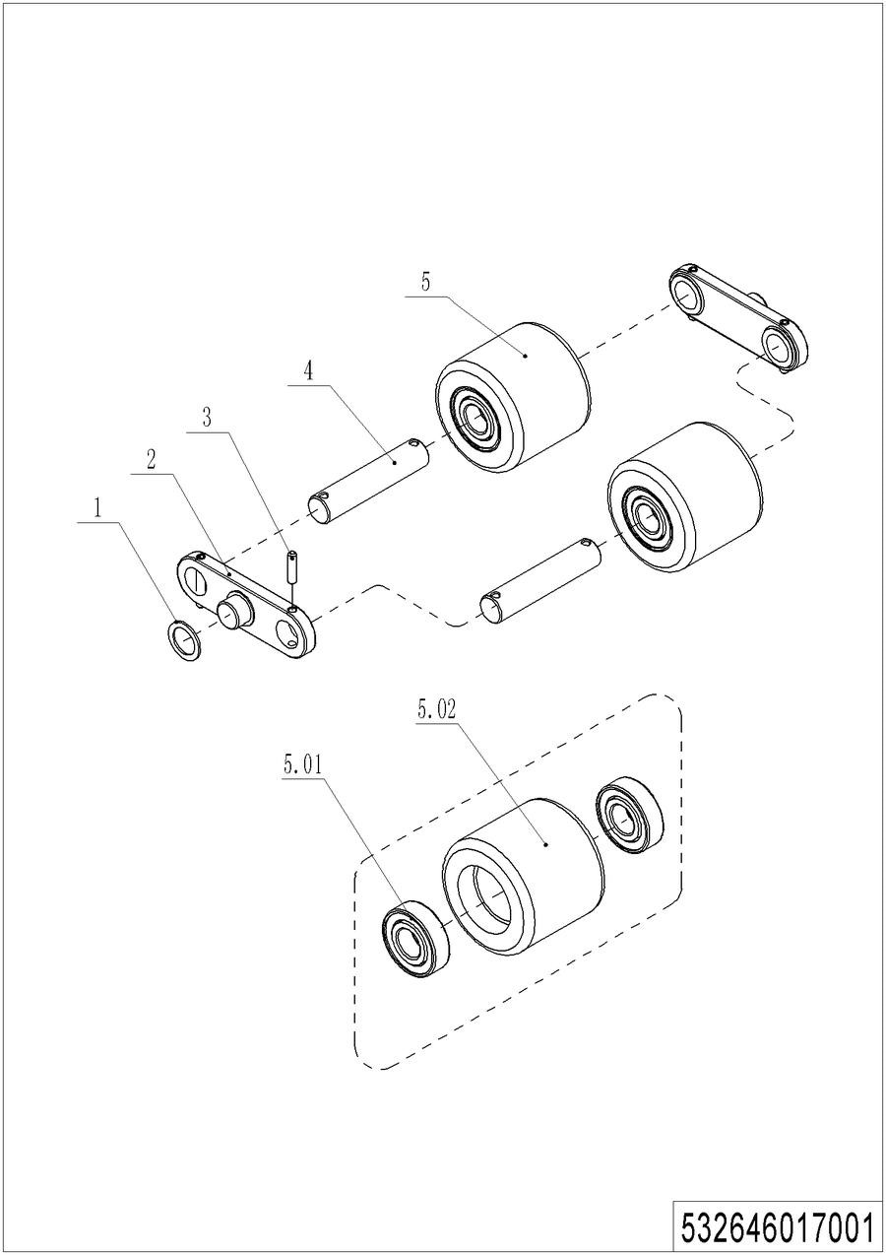
04 Load Wheel (532646017001)
No. | Item Code | Mark | Item Description | Qty. | Substitute | Note
1 | 940600500012 | 2 | Washer | 4
2 | 532617020002 | 2 | Plate | 4
3 | 910600400027 | 1 | Spring Pin | 8
4 | 502317020001 | 2 | Axle | 4
5 | 502398510002 |  | Wheel | 4
5.01 | 910700200019 |  | Bearing | 8
5.02 | 940300300005 |  | WheelΦ80x70 | 4

05 Caster (532246016501)
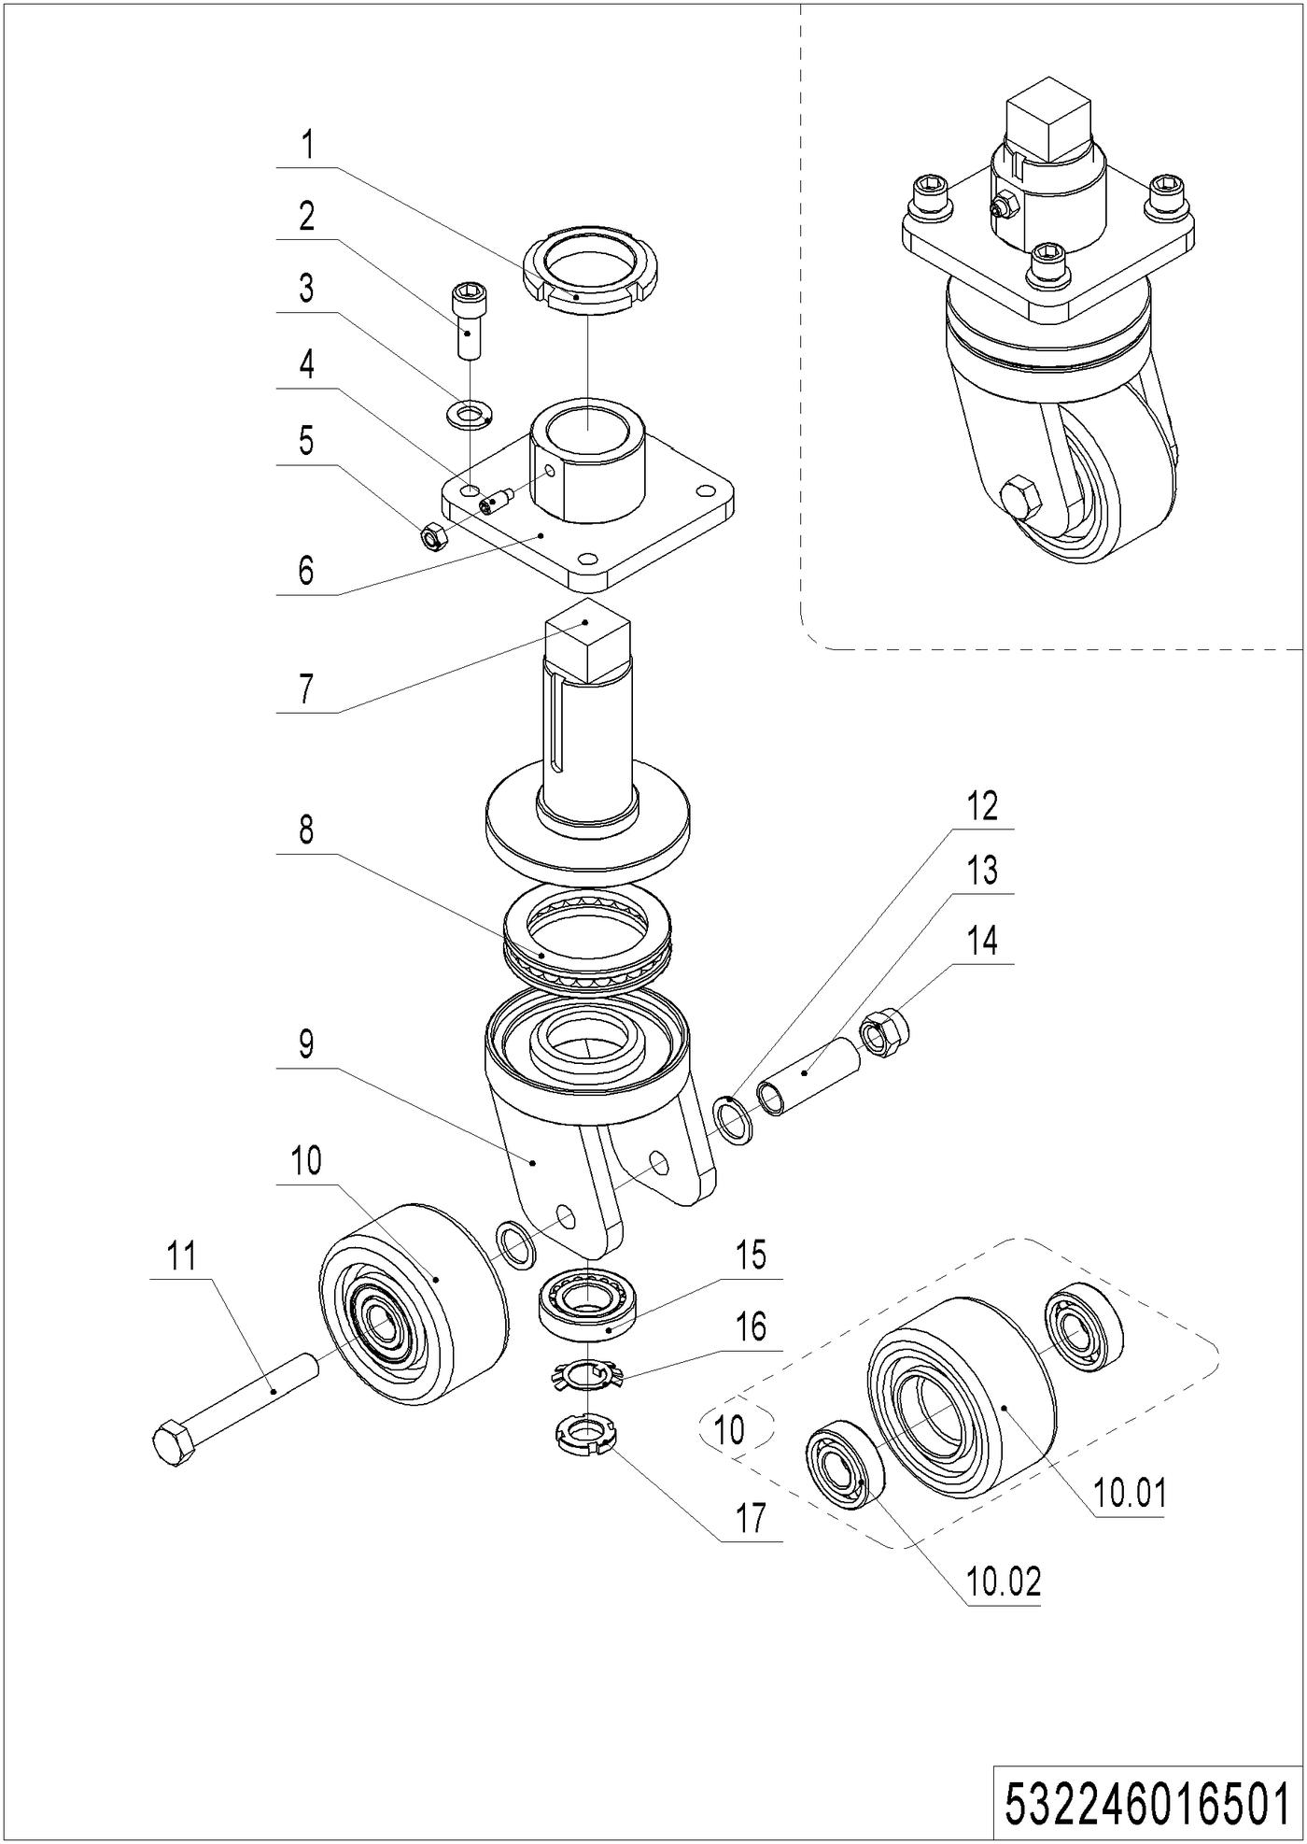
05 Caster (532246016501)
No. | Item Code | Mark | Item Description | Qty. | Substitute | Note
1 | 941100900004 | 1 | Nut | 1
2 | 910200200098 | 1 | Screw | 4
3 | 910400100008 | 1 | Flat Washer | 4
4 | 910201000012 | 1 | Screw | 1
5 | 910300100006 | 1 | Nut | 1
6 | 532216510003 | 2 | Fixing Base | 1
7 | 532216510002 | 2 | Axle | 1
8 | 910700700011 |  | Bearing | 1
9 | 532216510001 | 2 | Wheel Carrier | 1
10 | 532298510004 |  | Caster Assembly | 1
10.01 | 940300300030 |  | WheelΦ100x50 | 1
10.02 | 910700200019 |  | Bearing | 2
11 | 910100100069 | 1 | Bolt | 1
12 | 940600500005 | 1 | Washer | 4
13 | 532216520006 |  | Sleeve | 1
14 | 910300500007 | 1 | Nut | 1
15 | 910700600001 |  | Bearing | 1
16 | 910400900002 | 1 | Lock Washer | 1
17 | 910300700008 | 1 | Nut | 1

Chapter 5: Electrical Parts

01 Wire Harness (537246033001)
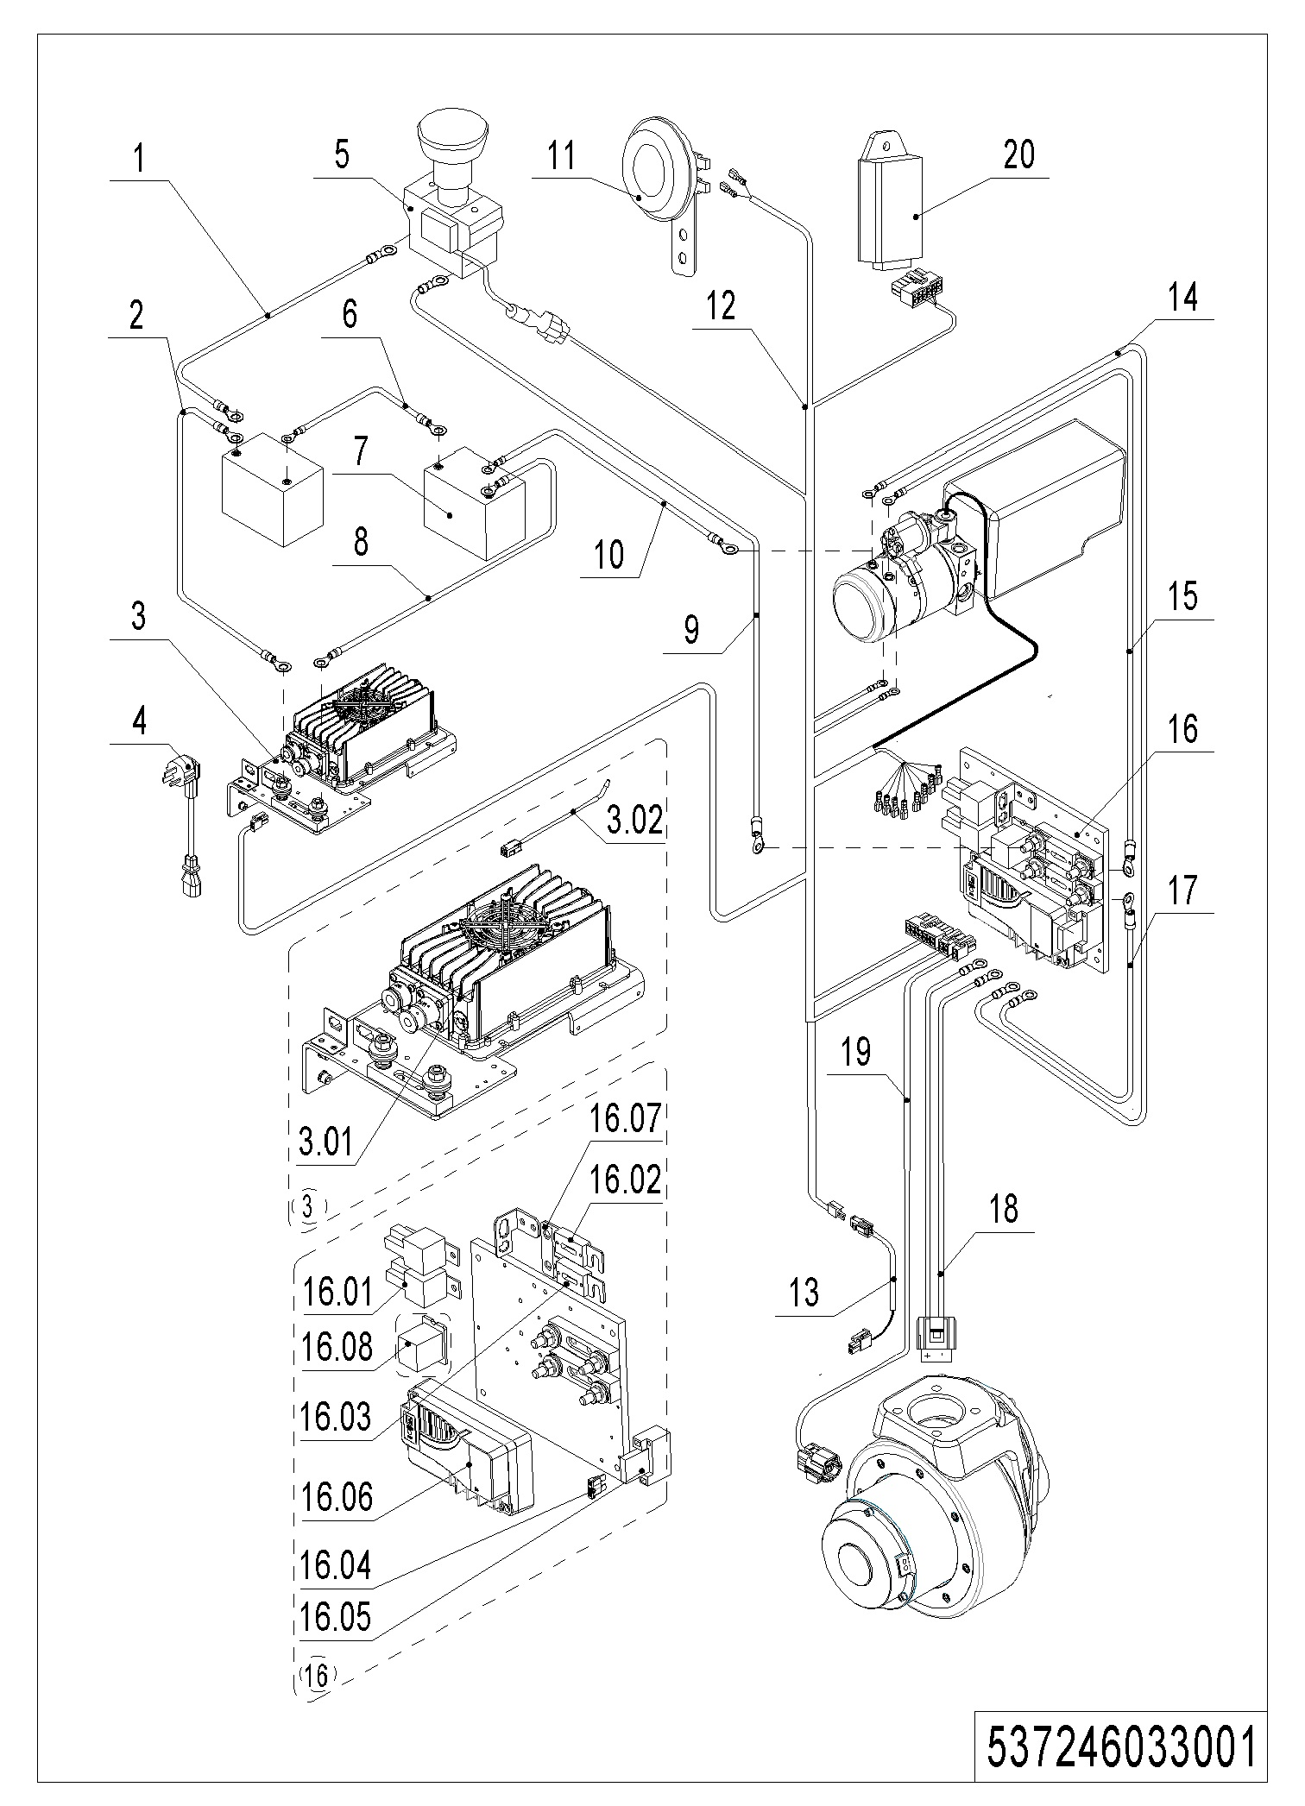
01 Wire Harness (537246033001)
No. | Item Code | Mark | Item Description | Qty. | Substitute | Note
1 | 537233010007 | 2 | Cable | 1
2 | 537233010012 | 2 | Cables | 1
3 | 537036510000 | 2 | charger24V15A(Asia) | 1
3 | 537036510001 | 2 | charger24V15A(ENG) | 1
3 | 537036510002 | 2 | charger24V15A(US) | 1
3 | 537036510003 | 2 | charger24V15A(EU) | 1
3 | 537036510004 | 2 | charger24V15A(AUS) | 1
3 | 537036510005 | 2 | charger24V15A(ITA) | 1
3 | 537036510006 | 2 | charger24V15A(SWE) | 1
3.01 | 921000100056 | 2 | Charger24V15A | 1
3.02 | 922000100025 | 2 | Lamp | 1
4 | 921500200008 | 2 | Spring Cable（Asia） | 1
4 | 921500200004 | 2 | Spring Cable(ENG) | 1
4 | 921500200002 | 2 | Spring Cable(USA) | 1
4 | 921500200005 | 2 | Spring Cable(EU) | 1
4 | 921500200003 | 2 | Spring Cable(AUS) | 1
4 | 921500200006 | 2 | Spring Cable(ITY) | 1
4 | 921500200007 | 2 | Spring Cable(SWD) | 1
5 | 920200100001 | 2 | Emergency Button | 1
6 | 537233010011 | 2 | Cable | 1
7 | 537237001000 | 2 | Battery12V100Ah | 2
8 | 537233010013 | 2 | Cables | 1
9 | 537233010002 | 2 | Cable | 1
10 | 537233010006 | 2 | Cable | 1
11 | 920500100001 | 2 | Horn | 1
12 | 537233010000 | 2 | Wire Harness | 1 |  | Chassis＞1600
12 | 537233010015 | 2 | Wire Harness | 1 |  | Chassis=1600
13 | 537233010017 | 2 | Wire Harness | 1 |  | With Temp Sensor
14 | 537233010006 | 2 | Cable | 1
15 | 537233010004 | 2 | Cable | 1

01 Wire Harness (537246033001) Continuation
01 Wire Harness (537246033001) Continuation
No. | Item Code | Mark | Item Description | Qty. | Substitute | Note
16 | 537233010014 | 2 | Electronic Components | 1
16.01 | 920800100011 | 2 | Relay | 2
16.02 | 920100100008 | 2 | Fuse | 1
16.03 | 920100100004 | 2 | Fuse | 1
16.04 | 920100200002 | 2 | Fuse | 1
16.05 | 920100400006 | 2 | Fuse Holder | 1
16.06 | 921400100097 | 2 | Controller | 1
16.07 | 505633020003 | 2 | Copper Busbar | 1
16.08 | 532033010023 | 2 | Module | 1 |  | With Temp Sensor
17 | 537233010003 | 2 | Cables | 1
18 | 537233010009 | 2 | Wire Harness | 1
19 | 537233010010 | 2 | Wire Harness | 1
20 | 921200100015 | 2 | Module DTJ00403A | 1

Chapter 6: Guard Arm, Platform

01 Guard Arm (537246017501)
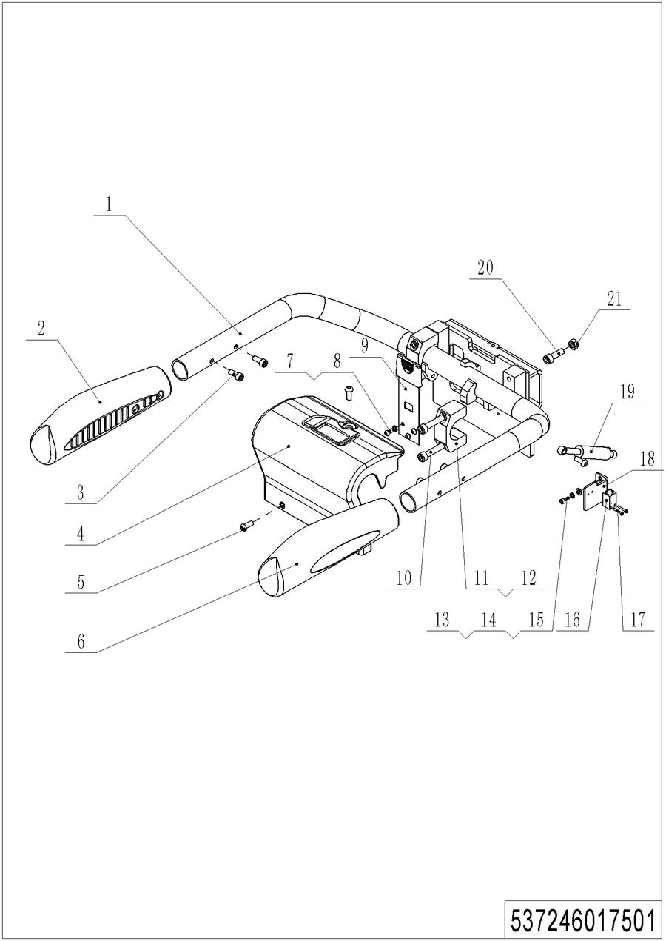
01 Guard Arm (537246017501)
No. | Item Code | Mark | Item Description | Qty. | Substitute | Note
1 | 537217510000 | 2 | Protective Arm | 1
2 | 505617510004 | 2 | Guard Arm Sleeve | 1
3 | 910200300025 | 1 | Screw | 9
4 | 509821520023 | 2 | Protective Cover | 1
5 | 941100100012 | 1 | Screw,M8x20 | 3
6 | 505617510002 | 2 | Guard Arm Sleeve | 1
7 | 910400500005 | 1 | Spring Washer | 3
8 | 910200300017 | 1 | Screw | 3
9 | 505617510005 | 2 | Leaf Spring | 1
10 | 910200200080 | 1 | Screw | 4
11 | 505617520005 | 2 | Fixing Base | 1
12 | 505617520021 | 2 | Friction | 1
13 | 910200200022 | 1 | Screw | 2
14 | 910400500004 | 1 | Spring Washer | 2
15 | 910400100004 | 1 | Flat Washer | 2
16 | 505633510001 | 2 | Proximity Switch | 1
17 | 910200500015 | 1 | Screw | 2
18 | 537217520009 | 2 | Reflector | 1
19 | 940400100006 | 2 | Air Spring | 1
20 | 910200200077 | 1 | Screw | 1
21 | 910300100007 | 1 | Nut | 1

02 Platform (537246018001)
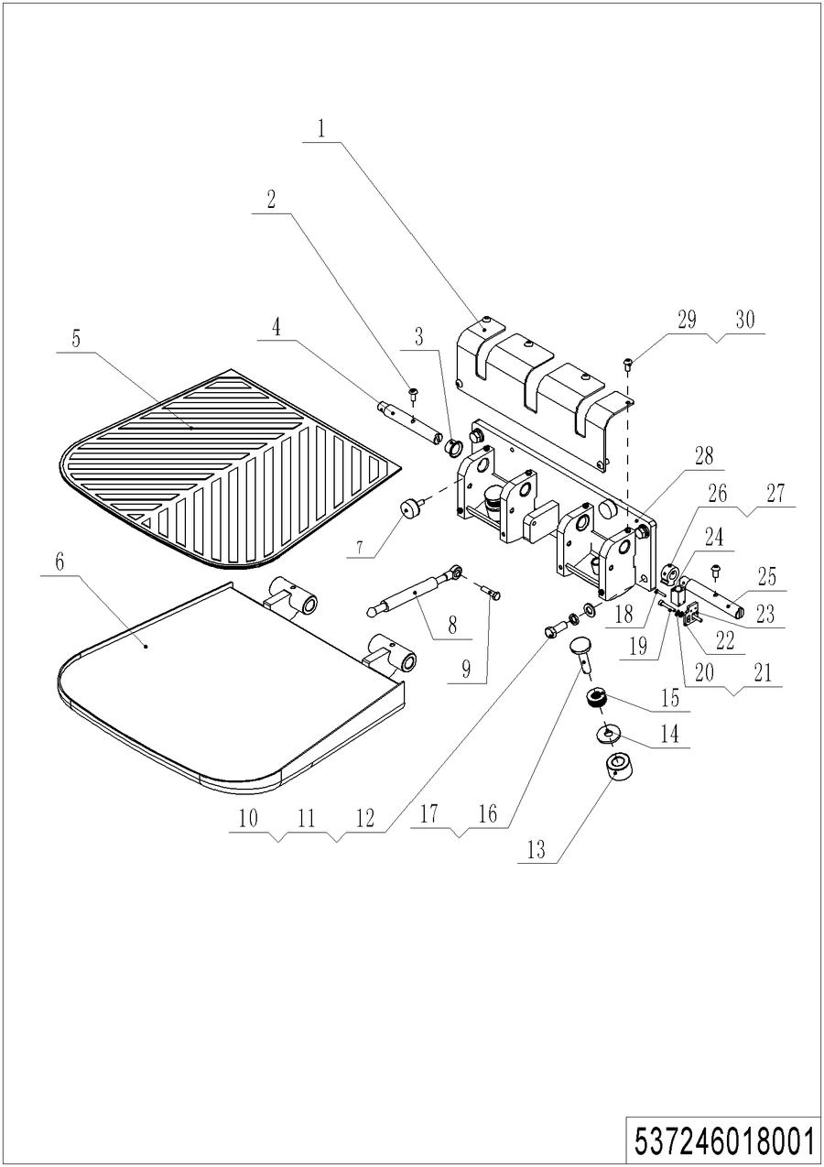
02 Platform (537246018001)
No. | Item Code | Mark | Item Description | Qty. | Substitute | Note
1 | 509818020004 | 2 | Protective Cover | 1
2 | 910200300018 | 1 | Screw | 2
3 | 505618020020 | 2 | Axle | 1
4 | 940500200008 | 4 | Bushing | 4
5 | 505618020018 | 1 | Rubber Mat | 1
6 | 509818010000 | 2 | Platform | 1
7 | 505618020016 | 2 | Crash Pad | 2
8 | 940400100039 | 1 | Air Spring | 1
9 | 910100300024 | 1 | Bolt | 1
10 | 910100300050 | 1 | Bolt | 4
11 | 910400500008 | 1 | Spring Washer | 4
12 | 910400100008 | 1 | Flat Washer | 4
13 | 505618020029 | 2 | Crash Pad | 2
14 | 505618020022 | 2 | Crash Pad | 2
15 | 505618020030 | 2 | Sleeve | 2
16 | 505618020021 | 2 | Pin | 2
17 | 910600600026 | 1 | Cotter Pin | 2
18 | 910200500015 | 1 | Screw | 2
19 | 910200200026 | 1 | Screw | 2
20 | 910400500004 | 1 | Spring Washer | 2
21 | 910400100004 | 1 | Flat Washer | 2
22 | 505618020026 | 2 | Mounting Plate | 1
23 | 505618020027 | 2 | Mounting Plate | 1
24 | 505633510002 | 2 | Proximity Switch | 1
25 | 505618020017 | 2 | Pin | 1
26 | 910200400005 | 1 | Screw | 1
27 | 505618020024 | 2 | Cam | 1
28 | 509818010001 | 2 | Mounting Base | 1
29 | 910400500005 | 1 | Spring Washer | 6
30 | 910200300017 | 1 | Screw | 6

Chapter 7: Special Parts

01 Load Backrest (Optional) (532646040501)
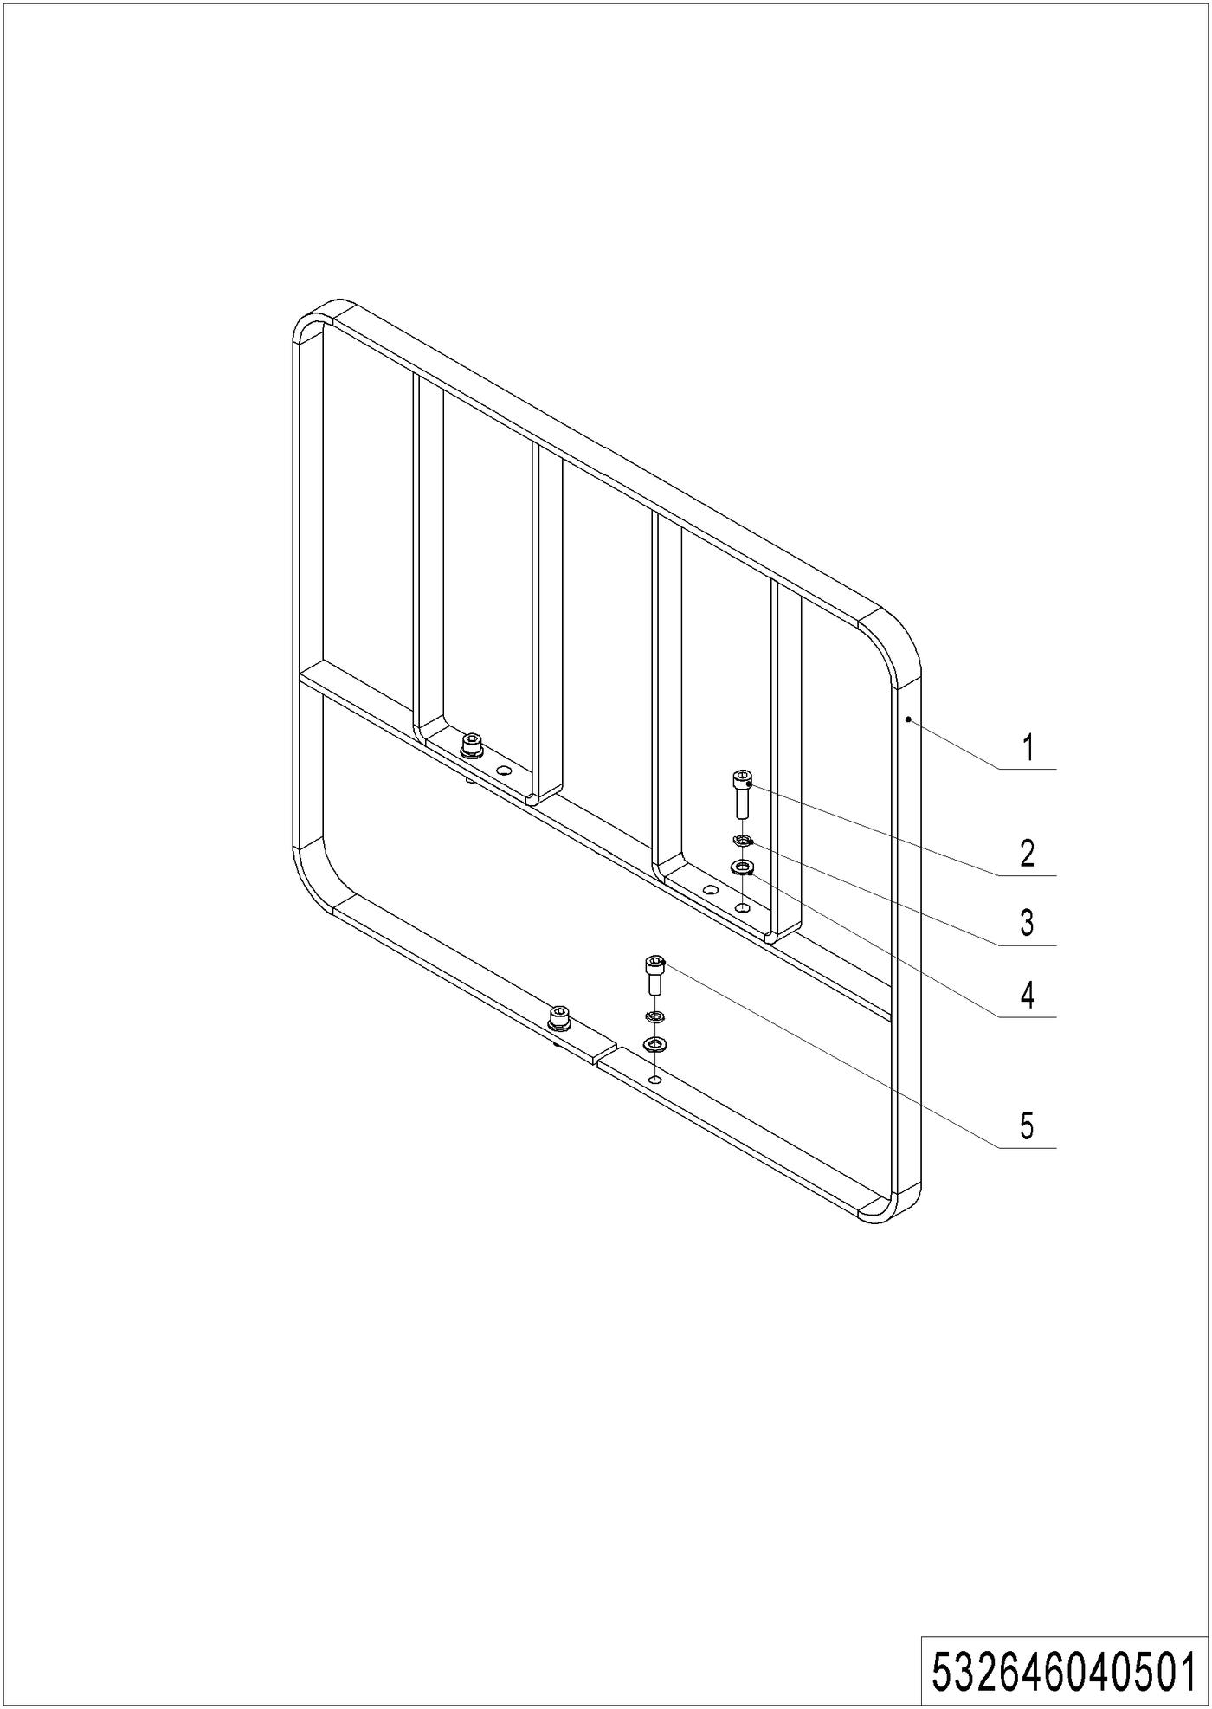
01 Load Backrest (Optional) (532646040501)
No. | Item Code | Mark | Item Description | Qty. | Substitute | Note
1 | 532640510001 | 2 | Load Backrest | 1
2 | 910200200077 | 1 | Screw | 2
3 | 910400500007 | 1 | Spring Washer | 4
4 | 910400100007 | 1 | Flat Washer | 4
5 | 910200200076 | 1 | Screw | 2

Chapter 8: Others

01 Labels and Decals-EU (537246047001)
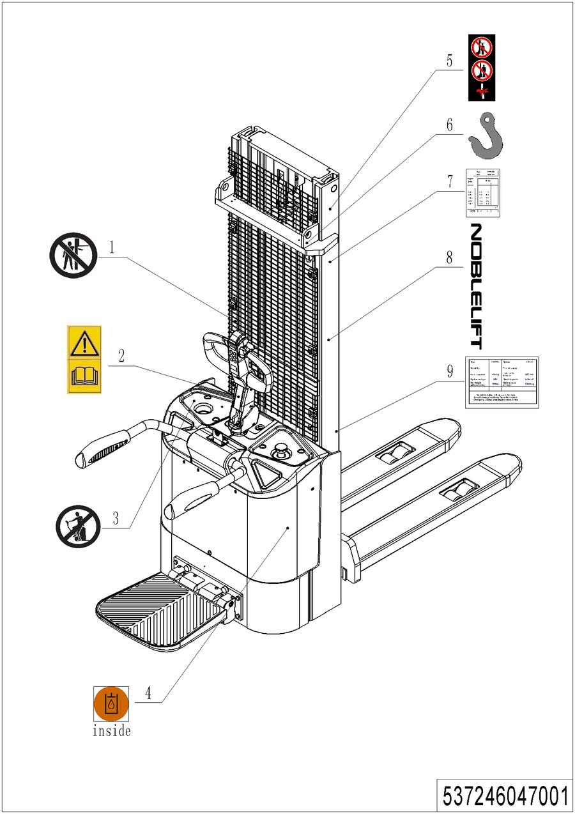
01 Labels and Decals-EU (537246047001)
No. | Item Code | Mark | Item Description | Qty. | Substitute | Note
1 | 941200100006 | 2 | Label | 1
2 | 941200300002 | 2 | Label | 1
3 | 941200100003 | 2 | Label | 1
4 | 941200300003 | 2 | Label | 1
5 | 941200100004 | 2 | Label | 2
6 | 941200300001 | 2 | Label | 2
7 | 537247520000 | 2 | Load Capacity Diagram | 1
8 | 941200500001 |  | Label | 1 |  | Depends On Customer
9 | 537247520016 | 2 | Truck data plate | 1

02 Labels and Decals-US (537246047002)
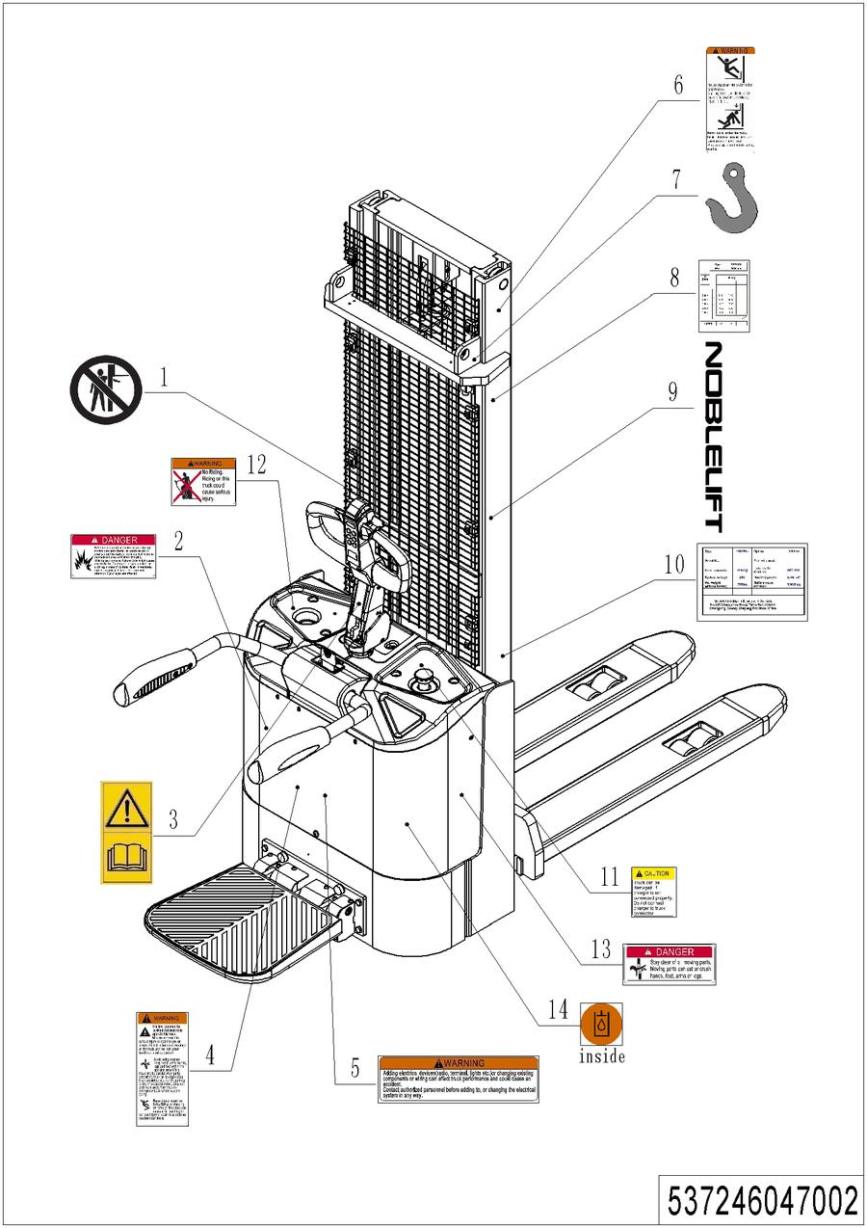

02 Labels and Decals-US (537246047002)
No. | Item Code | Mark | Item Description | Qty. | Substitute | Note
1 | 941200100006 | 2 | Label | 1
2 | 941200100013 | 2 | Label | 1
3 | 941200300002 | 2 | Label | 1
4 | 941200100009 | 2 | Label | 1
5 | 941200100010 | 2 | Label | 1
6 | 941200100016 | 2 | Label | 1
7 | 941200300001 | 2 | Label | 2
8 | 537247520000 | 2 | Load Capacity Diagram | 1
9 | 941200500001 |  | Label | 1 |  | Depends On Customer
10 | 537247520016 | 2 | Truck data plate | 1
11 | 941200100012 | 2 | Label | 1
12 | 941200100011 | 2 | Label | 1
13 | 941200100014 | 2 | Label | 1
14 | 941200300003 | 2 | Label | 1 |  | Chapter

Appendix

01 Electrical Circuit Diagram (537246045501)
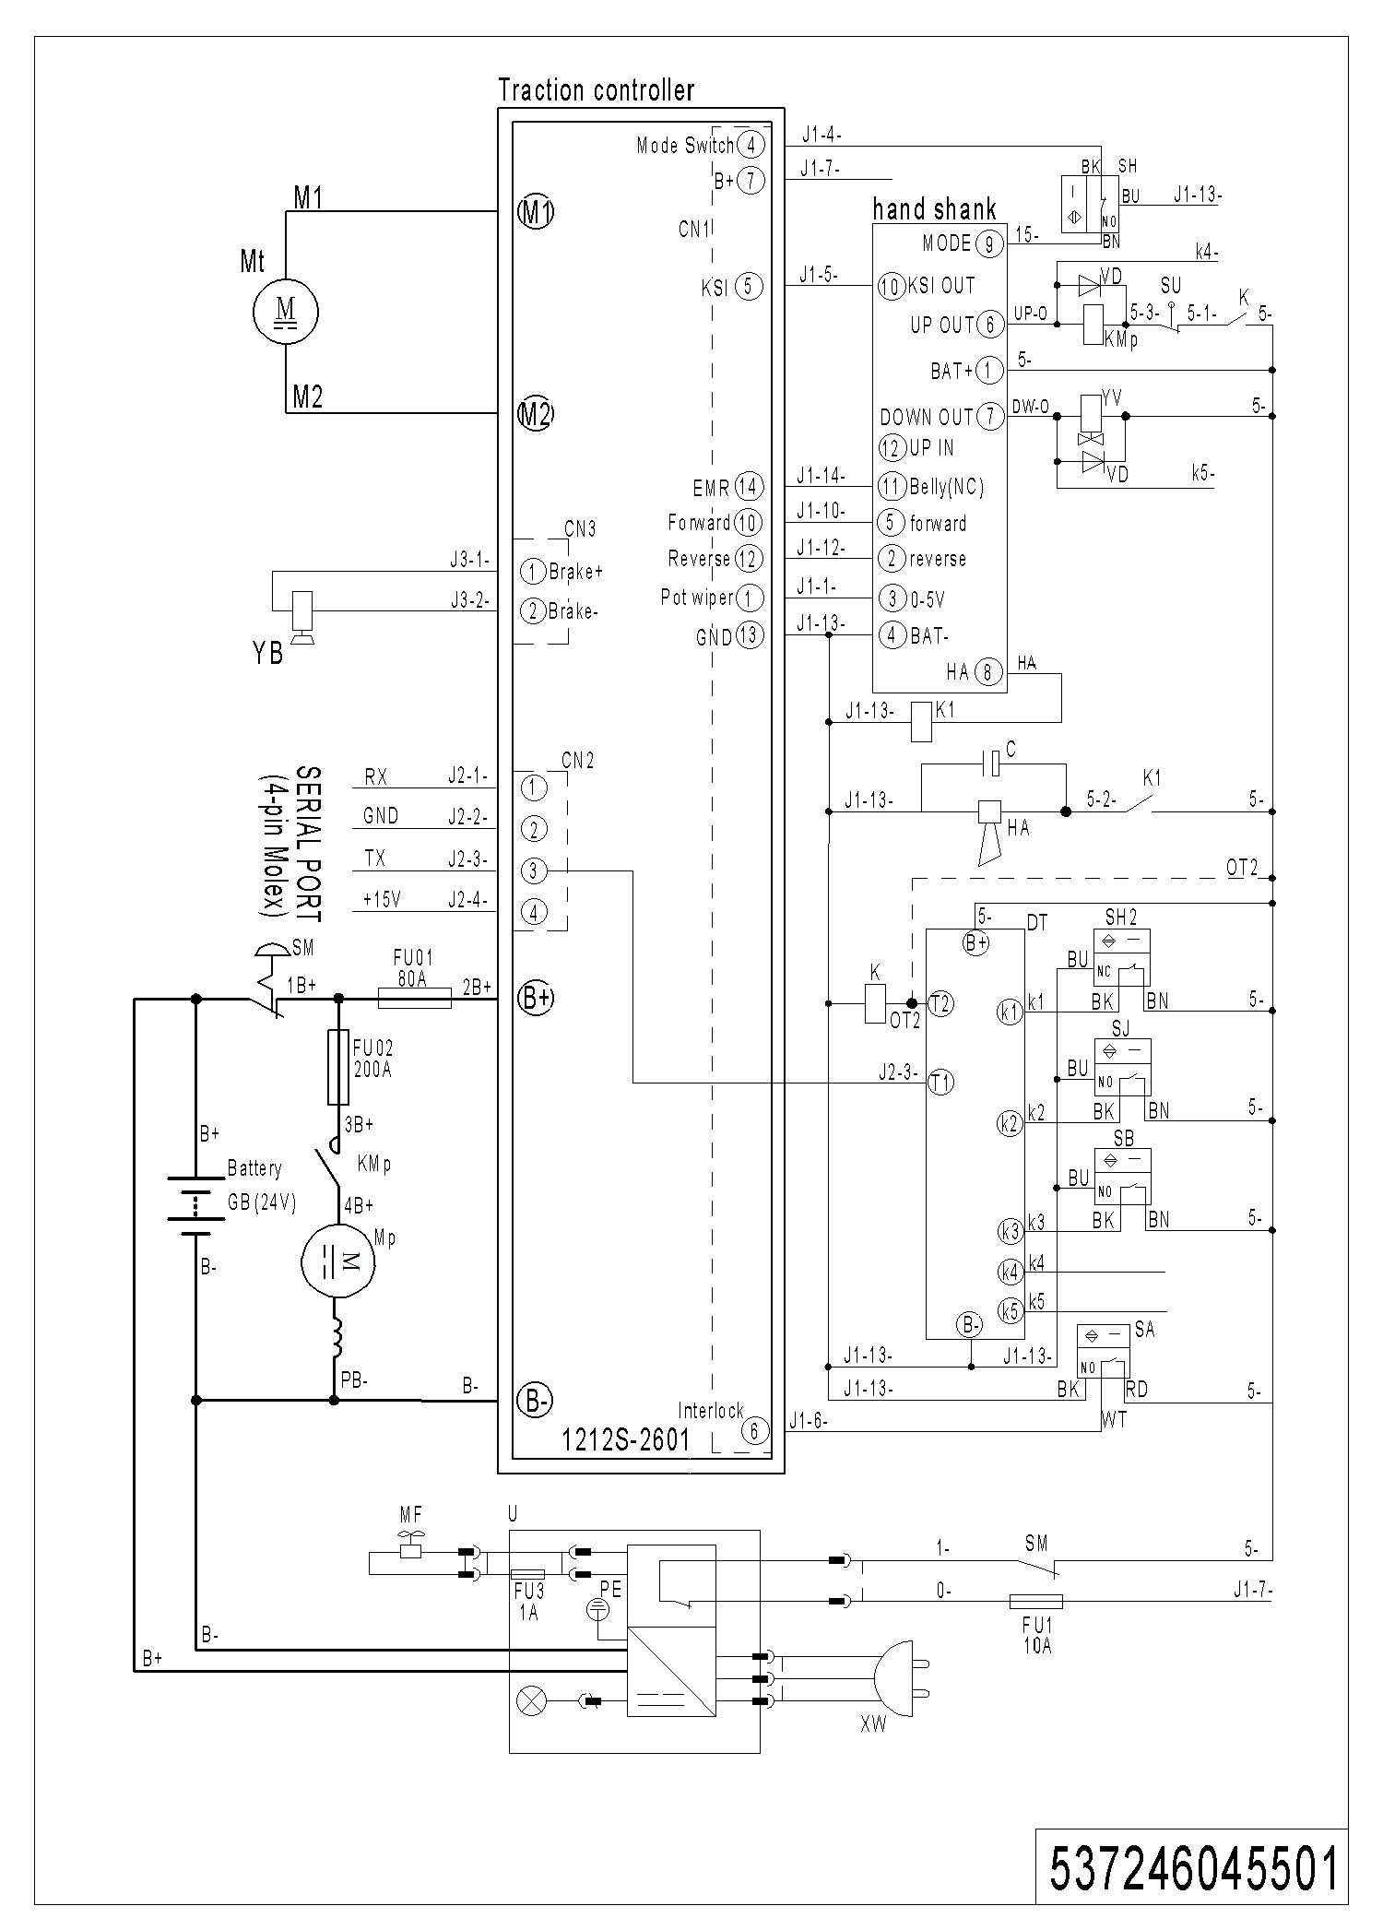

02 Hydraulic Circuit Diagram (537046045504)
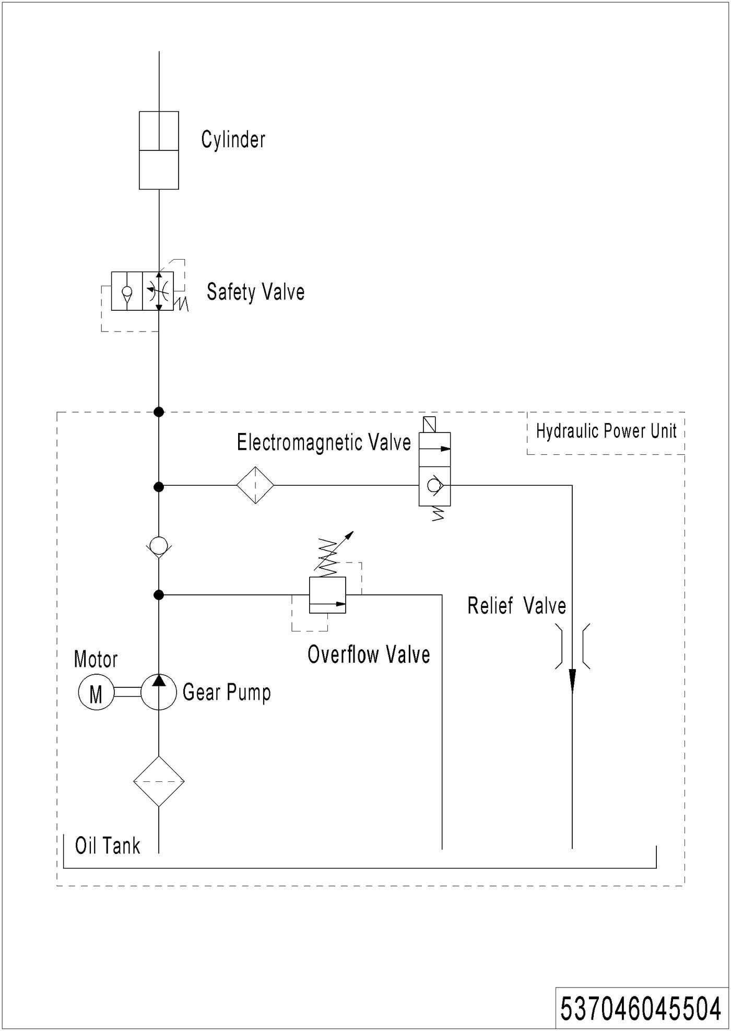

03 Consumable Parts List
No. | Item Code | Item Description | Qty. | Chapter/ Section/ Number
1 | 910700200008 | Bearing | 1 | Chapter1 /01/6
2 | 537098510015 | Carbon Brush | 1 | Chapter1 /02/1.01
3 | 910700200053 | Bearing | 2 | Chapter1 /02/3
4 | 532698510001 | Seal Kit | 1 | Chapter2 /01/7
5 | 532298510026 | Carbon Brush | 1 | Chapter2 /02/1.01
6 | 940400100044 | Air Spring | 1 | Chapter 4/01/5
7 | 940500200002 | Bushing | 1 | Chapter4 /01/10
8 | 910700200009 | Bearing | 1 | Chapter 4/03/1
9 | 910700200007 | Bearing | 1 | Chapter4 /03/10
10 | 502398510002 | Wheel | 4 | Chapter4 /04/5
11 | 910700700011 | Bearing | 1 | Chapter 4/05/8
12 | 532298510004 | Caster Assembly | 2 | Chapter 4/05/10
13 | 920100100004 | Fuse | 1 | Chapter 5/01/16.03
14 | 920100100008 | Fuse | 1 | Chapter 5/01/16.02
15 | 920100200002 | Fuse | 1 | Chapter 5/01/16.04
16 | 920800100011 | Relay | 2 | Chapter 5/01/16.01
17 | 920200300001 | Microswitch | 1 | Chapter3 /02/38 Chapter3 /03/34
18 | 920200400034 | Proximity Switch | 1 | Chapter 4/01/18
19 | 920200400033 | Proximity Switch | 1 | Chapter3 /02/39
20 | 920200400032 | Proximity Switch | 1 | Chapter3 /02/45 Chapter 3/03/36
21 | 505633510001 | Proximity Switch | 2 | Chapter6 /01/16
22 | 920200100001 | Emergency Button | 1 | Chapter5/01/5
23 | 940400100006 | Air Spring | 1 | Chapter6 /01/19
24 | 940500200008 | Bushing | 4 | Chapter6/02/4
25 | 940400100039 | Air Spring | 1 | Chapter6 /02/8

